

**GS-VMAS Newsletter**

April, 2021

*During 2021 we are planning for many interesting courses and workshops/seminars that we hope will be of interest for many. We are happy to announce a new series of events “Career after PhD studies” that we hope will inspire the PhD students when it comes to their future after the postgraduate studies. The first activity of this series is a seminar in May by Tove Fall, who is the SLU alumni of the year, and she will take us through her academic journey. We are already planning for the next event that will take place in the autumn and focus on possible careers outside of academia.*

**Seminars and workshops during the spring**

During the spring GS-VMAS has arranged/planned the following activities:

* Covid challenges for PhD students (19th of March)
* Life is an uncertain project, with Ingvard Wilhelmsen (21st of April)
* Finish on time – From efficiency to effectiveness (28th of April)
* Career after PhD studies – seminar with SLU alumni Tove Fall (12th of May)

**Covid challenges for PhD students**

With regards to the difficulties and challenges associated with the Covid-19 pandemic to pursue PhD studies GS-VMAS arranged a start-up webinar/workshop for PhD students and supervisors at the VH faculty where the following topics were discussed:

* What has worked well? Any positive experiences/routines that you will continue with after the pandemic?
* What has not worked well/been challenging?
* Ideas for actions that can be taken to improve supervision during the pandemic?
* Ideas on topics for digital webinar or other digital events with focus on these challenges?

A summary from these discussions has been sent to the head of each department and we hope that the discussions will continue at your departments.

GS-VMAS is planning a new workshop on this theme in June.

## **About funding - SLU Course organiser's guide**

Here is some general SLU information about funding for organising PhD courses:

As a researcher/supervisor employed at SLU you can apply for organising PhD courses. Funding is primarily provided by [SLU’s research schools](https://www.slu.se/en/education/programmes-courses/doctoral-studies/graduate-schools-at-slu/). For more information on GS-VMAS funding for organising PhD course, se below.

If you plan to organise a course together with colleagues at Nordic universities, members in the [NOVA university network](https://www.nmbu.no/en/students/nova/students/course-catalogue), and aim for participants from SLU and other international universities it is also possible to apply for funding from [SLU NOVA](https://internt.slu.se/en/support-services/education/doctoral-education1/doctoral-courses/slu-nova/).

## **Call for organising GS-VMAS PhD course 2022**

Time to plan for 2022. You will all receive a separate mail regarding the interest to organise PhD courses 2022 within GS-VMAS. With this we would like to remind you to send us your "*Notice of interest*" and/or suggestions for PhD-courses or other PhD-education related activities that you want to organize or wish that someone else can run. We look forward to input from PhD-students, supervisors as well as from all staff at our faculty.

We need to receive your suggestions **no later than May 15**. If you wish to organize a course please attach a notice of interest, a budget and an estimation of the number of post-graduate students who are potentially interested to attend according to the instructions at GS-VMAS homepage, [www.slu.se/gs-vmas-guide-course-organiser](http://www.slu.se/gs-vmas-guide-course-organiser).

If you want to organise some other activity such as a workshop or seminar please send an e-mail with a short description of the content and preliminary budget.

A second call for organising courses 2022 will be during autumn with a deadline of 15th November.

## **Call for organising NOVA course 2022**

[SLU NOVA](https://internt.slu.se/en/support-services/education/doctoral-education1/doctoral-courses/slu-nova/) will open for applications on March 16, for courses to be organized during 2021.  Application **deadline is May 15**. For more information, please visit: <https://internt.slu.se/en/support-services/education/doctoral-education1/doctoral-courses/slu-nova/>

**Upcoming GS-VMAS PhD courses 2021**

During 2021 we have many PhD courses throughout the year. At our webpage you can find course posters and registration links to those with a set start date as well as an excel-file with all courses planned during 2021. Please visit: <https://www.slu.se/en/graduate-schools/graduate-school-veterinary-medicine-and-animal-sciences/>

The following PhD courses are planned during the summer/early autumn:

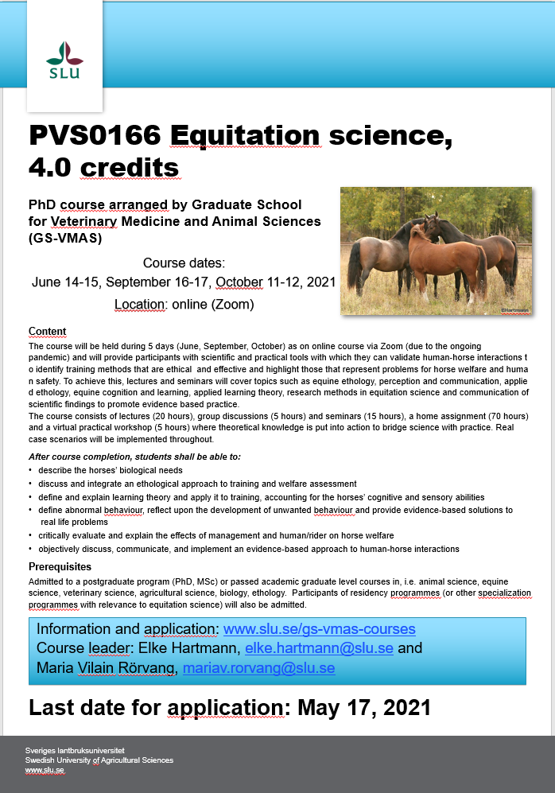 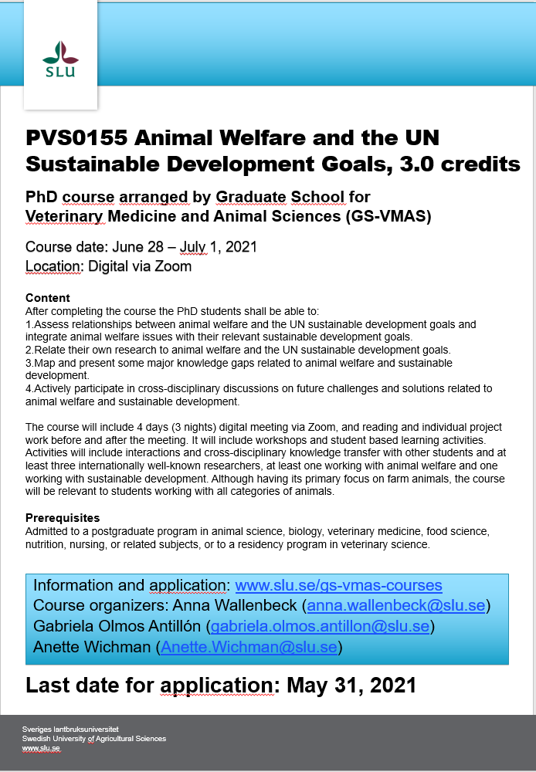

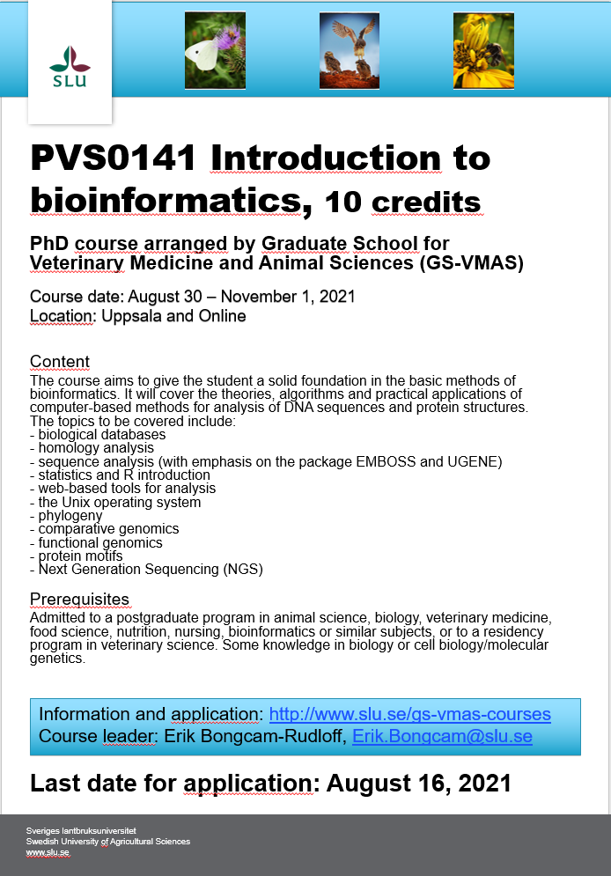 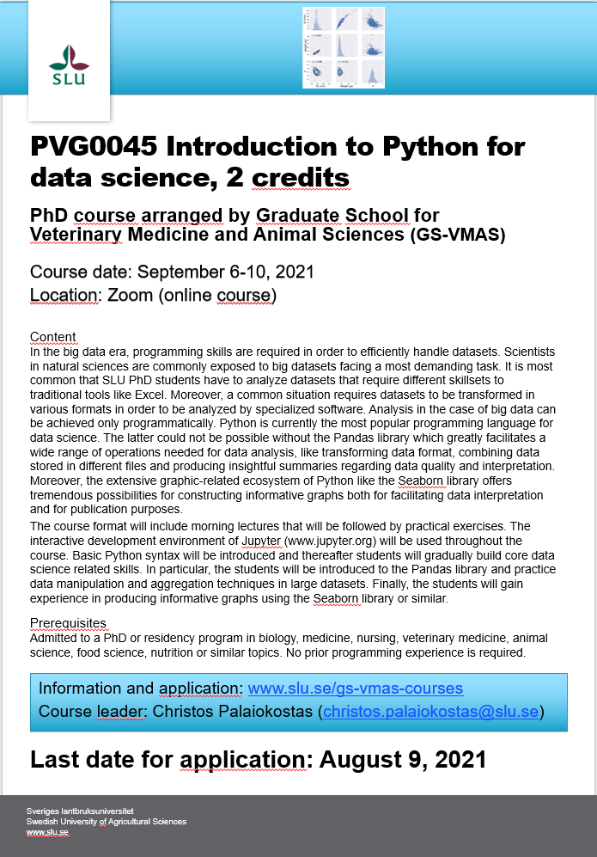 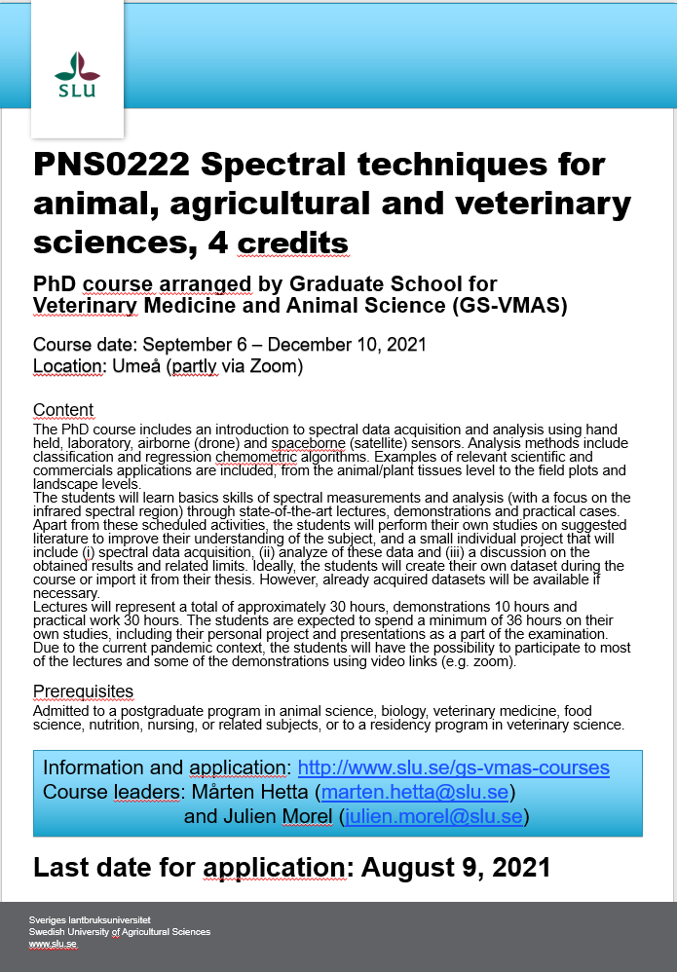

**SLU's general basic courses for PhD students**

For more information regarding SLU's general courses in transferable skills, please visit the [SLU webpage on Doctoral courses](https://internt.slu.se/en/support-services/education/doctoral-education1/doctoral-courses/).

**Mobility support**

The pandemic has restricted the possibility to travel and attend courses at other locations but if there is a course that you hope will still run in the later part of 2021 you are welcome with a mobility support application.

**Do you have an idea for a seminar or a workshop?**

GS-VMAS have funds available to grant money for seminars and/or workshops. If you have a visiting research partner or an opponent present for a dissertation it may be a great opportunity to combine this with arranging a seminar or workshop.

Please contact us at [gs-vmas@slu.se](mailto:gs-vmas@slu.se) and we will let you know whether there are funds available for your idea.

*All the best from the coordinators and administrators for GS-VMAS*

*Miia, Anne-Lie, Göran and Susanna*