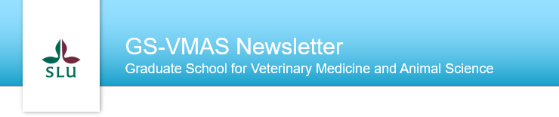
GS-VMAS Newsletter
February, 2021
The ongoing pandemic continue to greatly affect our lives both on and off work. Due to this unfortunately many PhD courses were cancelled 2020 but this year we have 21 courses planned that we hope will be of interest to many PhD students and residents at the faculty. In addition, we are planning for different digital events during 2021 focusing on career after the doctoral studies as well as on topics related to dealing with the current pandemic.
Upcoming new events within GS-VMAS
Digital webinars/events
Due to the difficulties and challenges associated with the Covid-19 pandemic to pursue PhD studies, GS-VMAS plans to arrange a couple of digital webinars/events for PhD students and supervisors during the 2021 spring semester with focus on these challenges. Our intention is to help PhD students and their supervisors find solutions to overcome such challenges.
We would like to get feedback from both PhD students and supervisors on suitable topics for these digital webinars or other digital events. Please let us know if you have any suggestions and ideas on themes and topics for these digital events. You may contact any of us coordinators directly or send an email to gs-vmas@slu.se.
Career after PhD studies
Have you considered what to do after your PhD studies? GS-VMAS are planning for some events where you will be able to get inspiration from some of our VH-alumni. Do you have any ideas on who or within which field you would like to hear from? Please contact any of us coordinators directly or send an email to gs-vmas@slu.se if you have any suggestions.
Planned courses 2021
For 2021 we have the following planned courses:
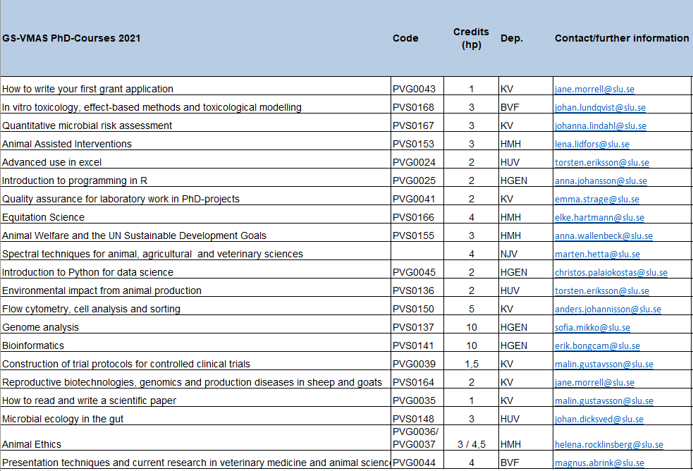
More information will be updated at the web www.slu.se/gs-vmas-planned-courses.
Presentation technique course at the VH Faculty
The course can be joined continuously by visiting https://slu-se.instructure.com/courses/1809 and clicking “Join the course” and logging in with your SLU account.
The course will include different workshops related to research presentation techniques - both to a scientific and a non-scientific audience. In addition, research students will also have practical training in giving seminars through presenting at the VH-faculty seminar series.
For more information, please visit: VH Presentation technique course | Externwebben (slu.se)
Upcoming PhD courses spring 2021
During spring 2021 we have the following upcoming courses:
- PVS0167 Quantitative microbial risk assessment
- PVS0153 Animal Assisted Interventions
- PVG0024 Advanced use in excel
- PVG0025 Introduction to programming in R
- PVG0041 Quality assurance for laboratory work in PhD-projects
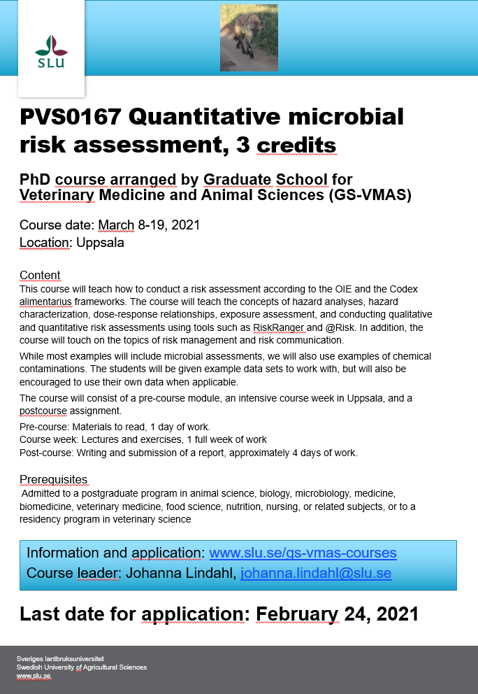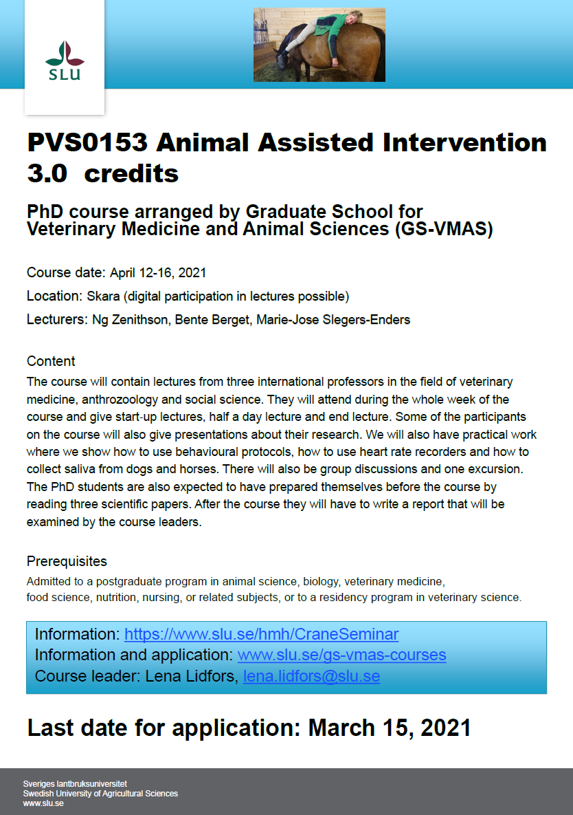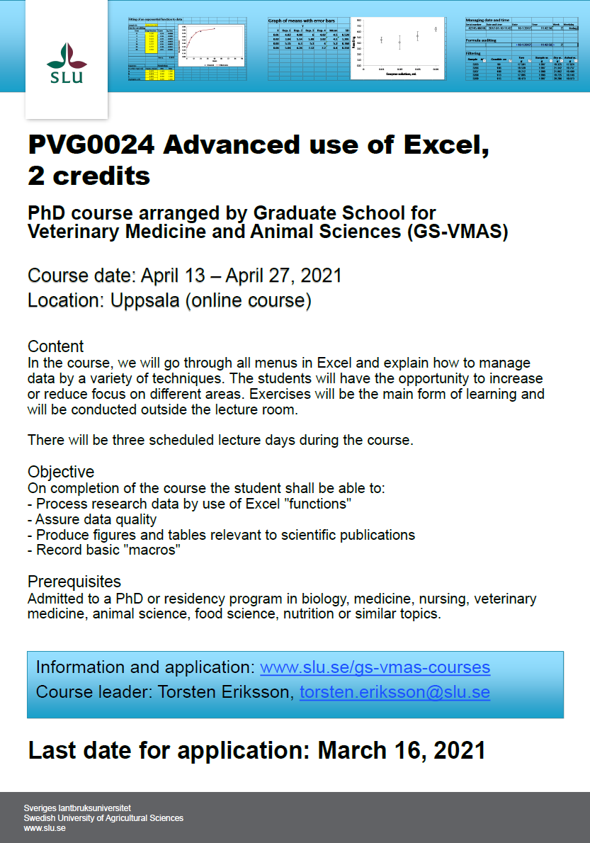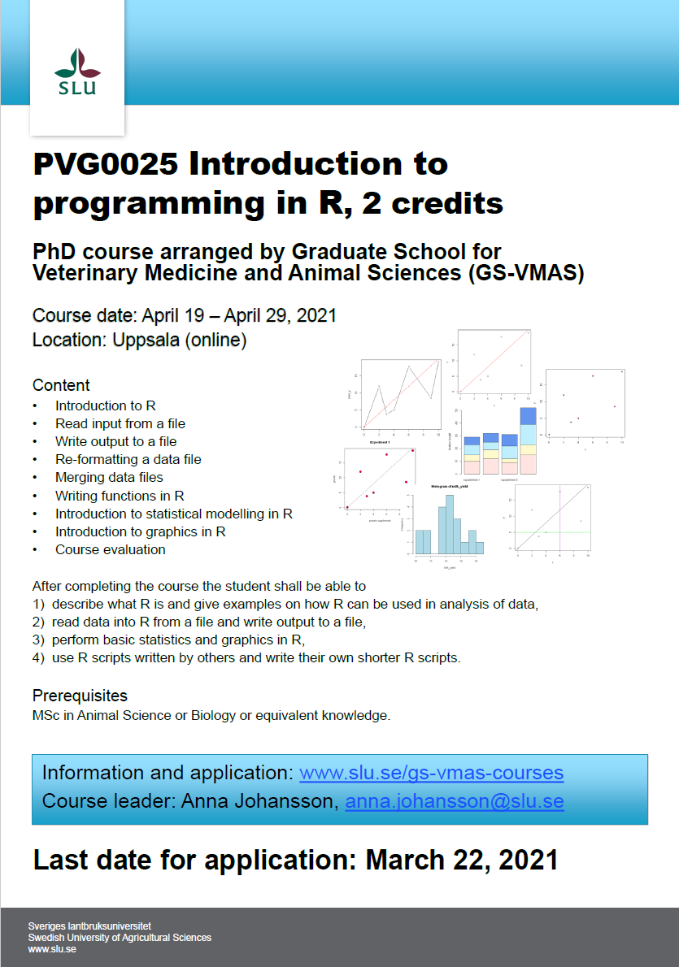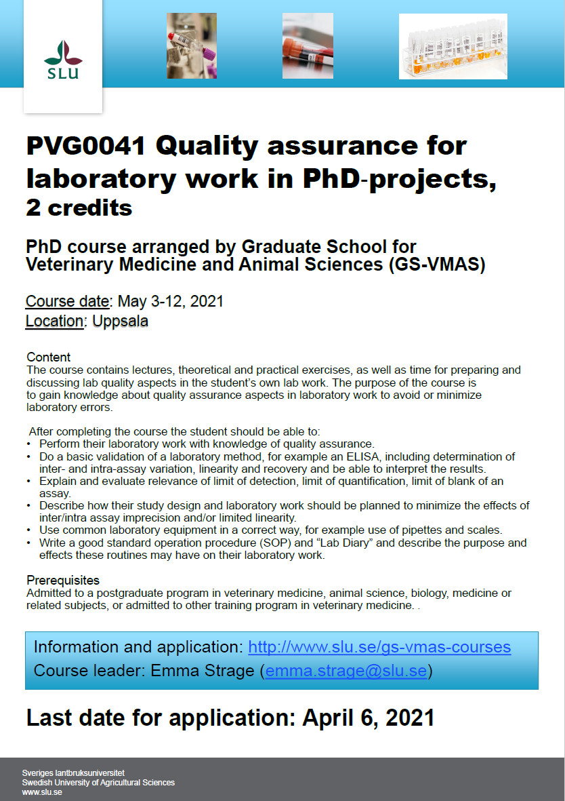
For more information and on-line application to courses, please visit: www.slu.se/gs-vmas-courses.
SLU's general courses for PhD students
For more information regarding SLU's general courses in transferable skills, please visit the SLU webpage on Doctoral courses.
Do you have an idea for a seminar or a workshop?
GS-VMAS have funds available to grant money for seminars and/or workshops. If you have a visiting research partner or an opponent present for a dissertation it may be a great opportunity to combine this with arranging a seminar or workshop.
Please contact us at gs-vmas@slu.se and we will let you know whether there are funds available for your idea.

Administration of your PhD studies
If you have any questions regarding the administration of your PhD studies, such as registration, crediting for courses, all courses completed in Ladok, you may use Education Services’ joint e-mail address for PhD matters: us-phd-vh@slu.se
All the best from the coordinators and administrators for GS-VMAS
Miia, Anne-Lie, Göran and Susanna

