

**GS-VMAS Newsletter**

September, 2021

*We at GS-VMAS have finished the first PhD-course call of the year and we are happy to announce that so far 13 courses are planned for 2022 but we hope to provide even more courses as we have now opened the second call (deadline 15th Nov). For the autumn we are planning activities such as a webinar about possible careers outside of academia and complementary to the “Finish on time” workshop that we arranged for PhD students during the spring we aim to arrange a related workshop for supervisors. Also don’t forget that we are accepting mobility applications from PhD- and resident students attending courses at other universities outside and inside of Sweden (see our webpage for further details).*

**Planned courses 2022**

For 2022 we have so far the following planned courses:

|  |  |  |  |  |
| --- | --- | --- | --- | --- |
| **GS-VMAS PhD-Courses 2022** | **Code** | **Credits (hp)** | **Dep.** | **Course leader** |
| Advanced use in Excel | PGV0024 | 2 | HUV | Torsten Eriksson |
| Introduction to programming in R | PVG0025 | 2 | HGEN | Anna M Johansson |
| How to write your first grant application | PVG0043 | 1 | KV | Jane Morell |
| Genome analysis | PVS0137 | 10 | HGEN | Sofia Mikko |
| Introductions to bioinformatics | PVS0141 | 10 | HGEN | Erik Bongcam |
| Digital tools and objective methods for motion research in animals |  | 3 | AFB | Elin Hernlund |
| How to read and write a scientific paper | PVG0035 | 1 | KV | Malin Gustavsson |
| Questionnaire Design and Management |  | 3 | KV | Jane Morrell |
| Reproducibility in Research with a focus on data analysis using the program R | PVG0038 | 2 | HGEN | Elisabeth Jonas |
| Ruminant Nutrition-Digestion and forage chemistry |  | 7 | NJV | Mohammad Ramin |
| Sperm Quality Evaluation | PVS0151 | 2 | KV | Jane Morrell |
| Animal Welfare and the UN sustainability goals | PVS0155 | 3 | HMH | Anna Wallenbeck |
| Animal Ethics | PVG0036/ PVG0037 | 3 / 4,5 | HMH | Helena Röcklinsberg |

More information on when each course will take place will follow and will be updated at the web [www.slu.se/gs-vmas-planned-courses](http://www.slu.se/gs-vmas-planned-courses).

During the autumn there will be a 2nd call for interest to arrange a PhD course during 2022, so there may be courses added to this list after that.

**2nd call for organising GS-VMAS PhD course 2022**

It is now time for our 2nd call for organizing GS-VMAS PhD courses 2022 and we are therefore keen to hear what PhD-courses you would like to organize next year. We need to receive your suggestions no later than 15th of November.

If you wish to organize a course please attach a notice of interest, a budget and an estimation of the number of post-graduate students who are potentially interested to attend according to the instructions at GS-VMAS homepage, [www.slu.se/gs-vmas-guide-course-organiser](http://www.slu.se/gs-vmas-guide-course-organiser).

**Upcoming PhD courses autumn 2021**

During autumn and winter 2021 we have the following upcoming courses:

* PVS0136 Environmental impact from animal production, 2 credits
* PVS0137 Genome analysis, 10 credits
* PVS0150 Flow cytometry, cell analysis and sorting, 5 credits
* PVG0036/PVG0037 Animal ethics 3 or 4,5 credits
* PVG0046 Survey methodology for questionnaire-based surveys, 4 credits

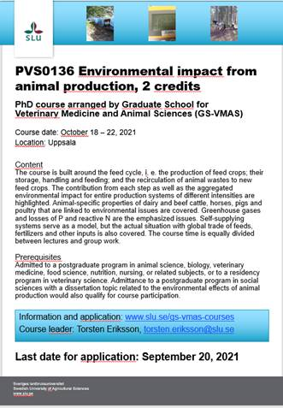  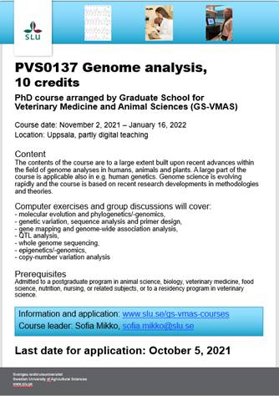  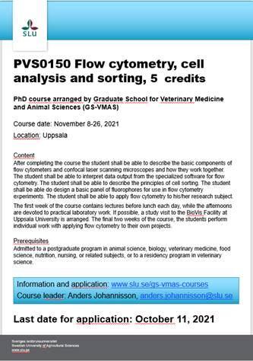

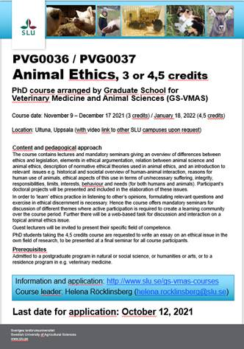  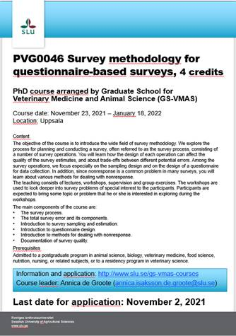

The following course is planned to be held December 6-7, provided that the course will be approved by FUN in time:

* Introduction to mechanics of soft materials, 4 credits

For more information and on-line application to courses, please visit: [www.slu.se/gs-vmas-courses](http://www.slu.se/gs-vmas-courses).

**Presentation technique course at the VH Faculty**

The VH-faculty have a seminar and presentation technique course, started in April 2020, with Magnus Åbrink from BVF as course leader. The course can be joined continuously by visiting <https://slu-se.instructure.com/courses/1809> and clicking “Join the course” and logging in with your SLU account.

The course includes different workshops related to research presentation techniques - both to a scientific and a non-scientific audience. In addition, research students will also have practical training in giving seminars through presenting at the VH-faculty seminar series.

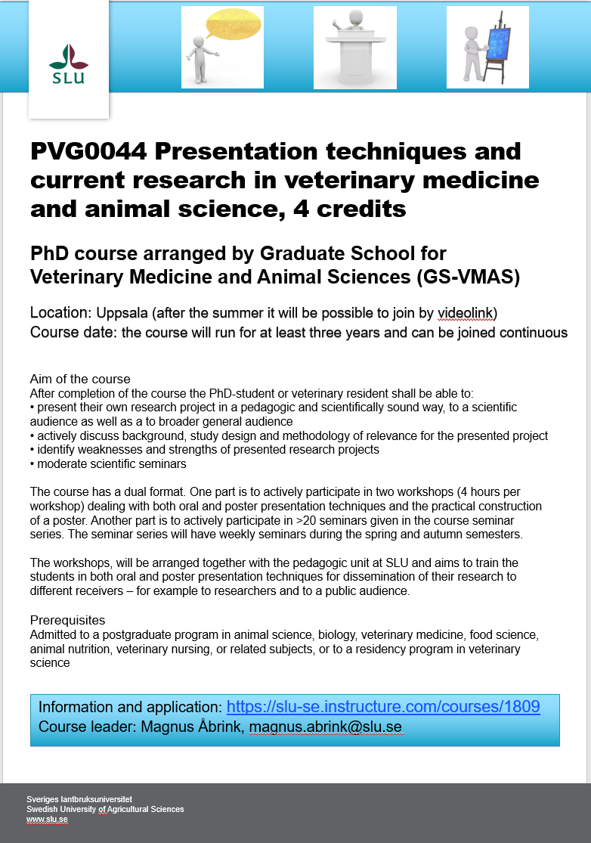

**SLU's general courses for PhD students**

For more information regarding SLU's general courses in transferable skills, please visit the [SLU webpage on Doctoral courses](https://internt.slu.se/en/support-services/education/doctoral-education1/doctoral-courses/).

**Do you have an idea for a seminar or a workshop?**

GS-VMAS have funds available to grant money for seminars and/or workshops. If you have a visiting research partner or an opponent present for a dissertation it may be a great opportunity to combine this with arranging a seminar or workshop.

Please contact us at [gs-vmas@slu.se](mailto:gs-vmas@slu.se) and we will let you know whether there are funds available for your idea.

## **Administration of your PhD studies**

If you have any questions regarding the administration of your PhD studies, such as registration, crediting for courses, all courses completed in Ladok, you may use Education Services’ joint e-mail address for PhD matters: [us-phd-vh@slu.se](mailto:us-phd-vh@slu.se)

*All the best from the coordinators and administrators for GS-VMAS*

*Miia, Anne-Lie, Göran and Susanna*