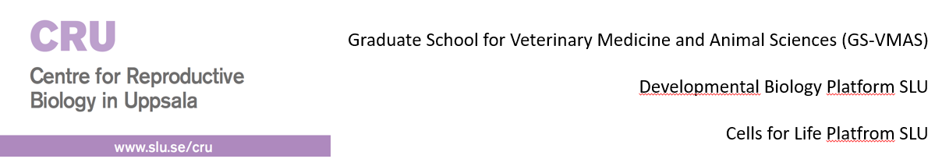
Summary of course in Comparative Reproductive Biotechnologies 2020
This course was organized with contributions from CRU, GS-VMAS and the SLU platforms Developmental biology and Cells for Life. The course was held completely online and 27 participants were admitted to take the course and all of these participants passed. The lectures were also attended by 20 extra participants from various organizations. The course had over 20 speakers and we are most grateful for the fantastic presentations. Course evaluations were very positive and we hope to be able to give a new version of the course in a few years’ time.

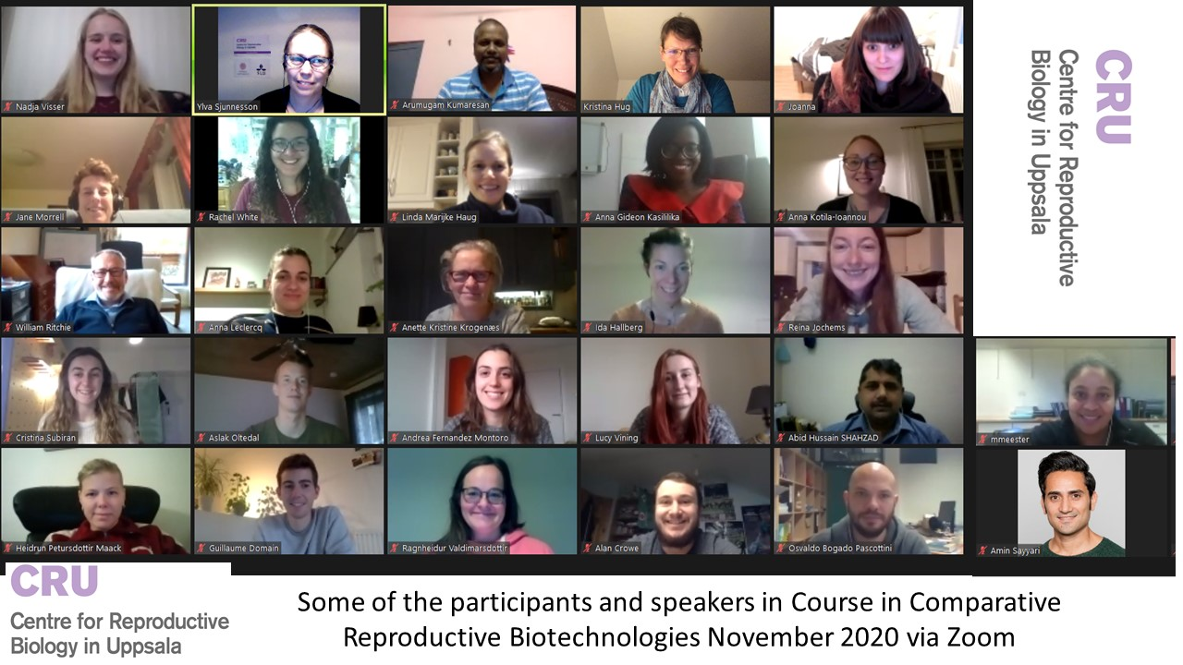

Final Schedule
Monday (Introduction/overview mammals and ovarian tissue) November 9
9:30 Introduction and practical information (Ylva Sjunnesson)
9:35 – 10:15 Sperm production, sperm collection and quality evaluation in animals (Jane Morrell)
10:25 – 10:55 Artificial insemination in animals and basic cryobiology (Jane Morrell/Eva Axnér)
11:05 – 11:45 Female cyclicity, fertilization and early embryo development in animals (Renée Båge)
11:45 Lunch
12:45 – 13:30 Participants own presentations session 1(Ylva Sjunnesson)
13:35 – 14:05 Endocrine manipulation in animals (Eva Axnér/Renée Båge)
14:15 – 14:45 Human cyclicity, fertilization and early embryo development (Anneli Stavréus-Evers)
14:45 – 15:05 Coffee break
15:05 – 15:35 Culture of human ovarian tissue (Pauliina Damdimopoulou)
15:45 – 16:15 Cryopreservation of human ovarian tissue (Claus Yding Andersen)
16:25 – 16:55 Endocrine manipulation in humans (Sarah Nordqvist)

Tuesday (Female focus) November 10
9:00 – 11:00 (including breaks) Human embryo production in vivo/in vitro including OPU, ICSI, IVF, Cryopreservation, ET and AI (Ludvig Ahrén)
11:05 – 11:35 Group discussions
11:35 Lunch
12:25 Participants own presentations session 2 (Ylva Sjunnesson)
13:10 Break
13:20 – 17:00 (including breaks) Animal embryo production in vivo/in vitro including OPU, ICSI, IVF, Cryopreservation, ET and AI (Ann Van Soom)

Wednesday: (Male focus) November 11
9:00 – 9:25 PGD and other tests (Erik Iwarsson)
9: 30 – 10:00 Selection of sperm in animals (Jane Morrell)
10:00 – 10:20 Coffee break
10:20 – 10:50 Testicular biopsies and transplants (Muren Herrid)
10:55 – 11:25 Cont.
11:30 Group discussions
12:00 Lunch
13:00 – 13:30 Selection and evaluation of human sperm (Thorir Hardarson)
13:30 – 13:40 Break
13:40 – 14:10 Testicular biopsies in human (Aleksander Giwercman)
14:10 Coffee break
14:30 – 17:00 Practical session 1

Thursday (Non mammalian species focus) November 12
9:00 – 9:45 Aquatic animals – basic info comparative aspects to mammals (Stefan Örn/Gunnar Carlsson)
9:45 – 9:50 Break
9:50 – 10:35 Zebrafish animal model in research; insights into breeding and reproductive research (Beata Filipek-Gorniok)
10:35 -10:55 Break
11:00 – 11:50 Basic bird reproduction and reproductive biotechnologies in birds (Lena Holm)
11:50 Lunch
12:50 – 13:20 Group discussions
13:30 – 14:15 Participants own presentations session 3 (Ylva Sjunnesson)
14:15 – 14:30 Coffee break
14:30 – 17:00 Practical session 2

Friday (Specialized aspects and ethics) November 13
9:00 – 9:40 Transgenesis and cloning (William Ritchie)
9:40 – 10.00 Coffee break
10:00 – 10:40 Cont.
10:50 – 11:30 How assisted reproduction techniques can contribute to conservation breeding programs of endangered species (Katarina Jewgenow)
11:30 – 12:00 Group discussions
12:00 – 13:00 Lunch
13:00 – 13:45 Epigenetic effects of reproductive biotechnologies and LOS (Patrice Humblot)
13:45 – 14:05 Coffee break
14:05 – 16:00 Ethics and animal welfare workshop (Olle Torpman and Kristina Hug)
16:00 – 16:30 Evaluation and course certificates (Ylva Sjunnesson)

Practical sessions included demonstrations of CASA (various species), freezing and thawing of dog semen, in vitro embryo production laboratory study visit (pig, cow, cat), aquatic laboratory study visit, AI in pig and cow.

