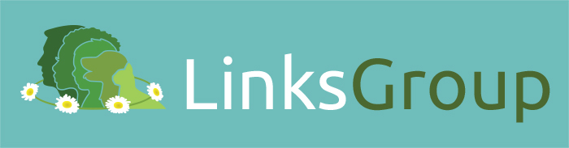

Summary of presentation
The concept of ‘One Welfare’ recognises the interconnections between animal welfare, human wellbeing and the environment. The Links Group promotes this aspiration, firmly believing that vets and the wider veterinary team have a role to play in helping to prevent animal abuse, domestic abuse, and child cruelty. Our mantra might be described as:
Making the Links - Making a Difference
Breaking the Link - Breaking the Cycle of Violence

The presentations will give a wide-ranging viewpoint on the theme of animal and human abuse. To put the topic in context, Freda gives a brief history of the Links Group and the various ‘shades of violence’ in households where humans and animals are at risk, introducing the concept that in a violent household:
“When animals are abused, people are at risk; when people are abused, animals are at risk.”
Quote from:
Understanding the Link between Violence to People and Violence to Animals
American Humane Association

Some of the initiatives that the Links Group has undertaken:
- promoting multi-agency working with human healthcare professionals and the police domestic violence teams
- improving the knowledge of veterinary professionals through the publication of concise and comprehensive guidance documents (www.bva-awf.org.uk/advice-vets/recognising-abuse-animals-humans)
- training courses through the Links Veterinary Training Initiative to ensure in-depth understanding of the A V D R technique (akin to ASK and ACT cf Welsh National Strategy)
- educating vets about abuse; confidentiality; note-taking; offering help to victims and seeking advice; keeping safe
- designing an online course for human healthcare professionals so that they can recognise and assess the risks to an animal’s wellbeing in a violent household
- working with Crimestoppers to ensure that reports of animal and / or human abuse can be successfully (and anonymously) reported
History of the Links Group
The Links Group came into existence following a conference in November 2001 called ‘Forging the Link’ and the natural question from the vets present was: "link to what"? However, the conference clearly illustrated to 150 delegates the link between animal abuse, cruelty to children and domestic violence. The speakers from both human and animal healthcare backgrounds demonstrated that non-accidental injury in our pets or farm animals may be an indication that there is going to be, or already is, violence against a person (or persons) in the same household.

It was notable that there were few veterinary delegates at the conference, perhaps reflecting lack of knowledge at the time of this abhorrent topic, despite the fact that earlier in 2001 Helen Munro (veterinary pathologist) and Mike Thrusfield (veterinary epidemiologist) had published a series of four papers in the Journal of Small Animal Practice, which coined the term 'the battered pet'. This was pioneering work and was the first time a large study had looked at the pathological findings from cases of 'non-accidental injury' (NAI) in the dog and cat. Many vets had not read the papers, or possibly not fully comprehended the implications of the pathological findings detailed in the Journal.

It was evident to those few vets present at the conference that members of the veterinary team needed to become better informed and a decision was made to form a multi-agency group with a common interest: to promote the safety and welfare of vulnerable children, animals and adults so that they are free from violence and abuse. Both vets and human healthcare professionals came together to better understand what could be done to intervene in the cycle of violence.

Progress in the veterinary world has been slow and it is apparent that vets fall into three categories: those who don't recognise or claim to never see abuse; those who recognise non-accidental injury but choose to ignore it; and finally a growing cadre of people who recognise that they are seeing evidence of NAI and want to do something about it.

There have been a number of barriers to progress; not least the understandable apprehension that by reporting incidences of non-accidental injury to the authorities there is a risk of driving animals away from treatment, just when they need it most. The fundamental question for the vet remains: “Did I do everything I could to ensure that animal’s welfare?” However as awareness of abuse grows within the profession, vets and other members of the veterinary team have questions; for example: "I once saw a dog that had been starved to death; later that owner was prosecuted for starving a child - could I have made a difference?"

Confidentiality
There is still overwhelming concern about breaching client confidentiality. Ten years ago, the veterinary surgeon’s Code of Professional Conduct (www.rcvs.org.uk/advice-and-guidance/code-of-professional-conduct-for-veterinary-surgeons) gave superficial advice with little useful direction for vets in practice. Vets were looking for information and found that there was little that was easily accessed. Calls to the Royal College of Veterinary Surgeons and other professional indemnity organisations like the Veterinary Defence Society (VDS) increased, as vets faced challenging consultations where NAI was suspected. Occasionally, calls relating to the links between animal, child and domestic abuse are received, specifically where a vet or veterinary nurse suspects that a child or adult within the home might be at risk. There are one or two calls every month on this issue. To assist, the RCVS has recently published updated guidance on dealing with child and domestic abuse (see www.rcvs.org.uk/confidentiality) and members of the Professional Conduct department are happy to discuss cases in more detail before any potential breaches are made.

Guidance documents
The Links Group have produced guidance for the veterinary profession as a concise document answering questions about abuse, and sign-posting members of the veterinary team to where they can get help. One of the difficulties lay in the section where practices need guidance in their approach to other agencies; either to report (if animal abuse is found) or to get advice about violence to vulnerable humans. Obviously the main responsibility of the veterinary surgeon is to the animal under their care and most practices have excellent relationships with the animal welfare agencies. The situation becomes more complex when a vet is faced with a human victim, or receives a disclosure of violence in a household. In the first instance, the practice is directed to the Professional Conduct Department of the Royal College of Veterinary Surgeons, only an option in normal working hours demonstrating the need for vets to have confidence in knowing what to do.

The Links Guidance documents stress that Through a link with Medics against Violence, a Scottish charity set up by mainstream healthcare workers and funded by the Scottish Government, the technique known as A-V-D-R (ask, validate, document and report/refer) was adopted as being an effective way to approach a difficult situation. The involvement of the vet when faced with a human victim is limited to offering a sympathetic ear and encouraging an adult victim to seek help. The Links Group have produced additional materials to offer the victim, including a contacts card specific to England, Wales and Scotland, giving them welfare agency contact details where they can seek help.

The Guidance document also encourages the development of local relationships with the police through a named contact; most British police forces have dedicated teams that tackle domestic abuse. They are aware of the links between domestic abuse and pet abuse, acknowledging the heightened risk for victims when their pets have been abused. They recognise that for many victims of domestic abuse, pets are a source of comfort providing strong emotional support for them and their children; however perpetrators often exploit this bond. Victims of violence will often delay leaving their homes because they cannot take their pets with them; this can have devastating results on the health and wellbeing of both the victim and their animals and in some cases, this delay has resulted in the death of a victim. The abuse of multiple pets may provide the police with an opportunity to link cases of domestic violence where perhaps evidence was lacking for court purposes as a single event, which explains their willingness to work with veterinary practices.

External collaborations
The Links Group now collaborates with Crimestoppers to provide another avenue of help for members of the veterinary team. Crimestoppers is an independent crime-fighting charity offering an anonymous and secure 24/7 service for third party information about domestic abuse or any other crimes, including animal abuse. Crimestoppers emphasizes that they are not the police, nor are they a TV programme. Crimestoppers have recognised that vets, veterinary nurses and receptionists are on the front line when it comes to dealing with NAI in animals or victims of domestic abuse and informative pocket cards are circulated to local practices. Reports to Crimestoppers of suspected abuse are made anonymously either by phone or online and can really help by providing one small part of what might be an extensive network of abusive incidents.

Undergraduate training
Recognising that veterinary undergraduates received little training in how to recognise the signs of animal abuse, the pharmaceutical company MSD Animal Health financially support annual lectures to 4th or Final Year students nearly all the veterinary schools in the UK. Undergraduates now leave veterinary school with an enhanced perception of how to recognise the signs of abuse.

Understanding Animal Welfare: for the Human Healthcare Professional
From 2017, an online course is available to colleagues in human healthcare. This deals with the issues that arise when animals are trapped in violent households. The course helps the police, healthcare visitors and social workers to recognise good welfare by understanding signposts to pets’ wellbeing. On completion of the course, they know how to recognise signs of neglect or abuse; understand the link between human abuse and animal abuse and what to do about it; where to get help; how to contact a vet for advice. This is a prime example of all that is good in ‘One Welfare’; see below.

So, that’s what we do – make Links; learn from others, answer questions, provide training, share experiences, establish liaisons….. Support for the work of the Links Group has grown substantially and cooperation between all healthcare professionals, both human and veterinary, is stronger than ever; doors to liaison have opened in most unexpected places; and other countries (Canada, Australia, Portugal, Australia, Norway, Sweden, Belgium and the Netherlands) are taking an active interest in our work.

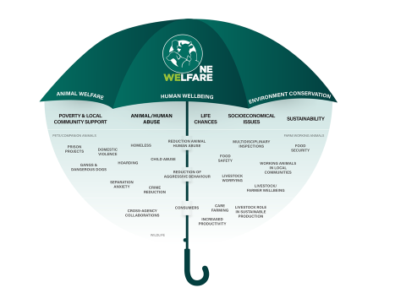
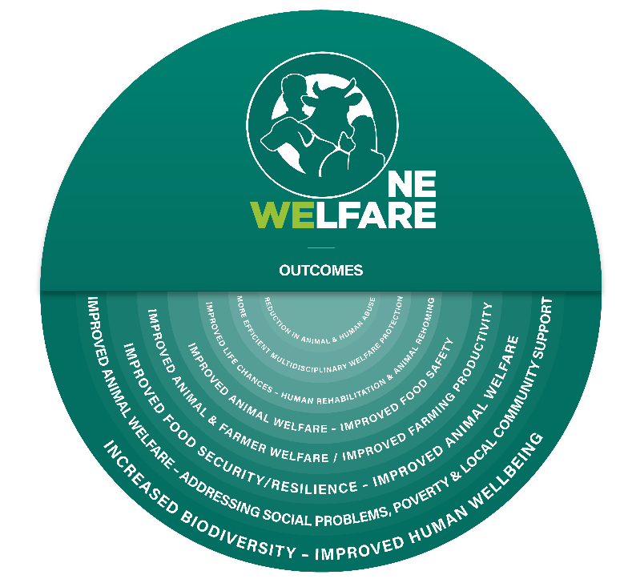

USEFUL REFERENCES
Munro HMC. Thrusfield MV. J Small Anim Pract 2001: 42, issues 5-8, 218-226; 279-290; 333-337; 385-389
Munro, R. Munro HMC. Animal Abuse and Unlawful Killing; Forensic Veterinary Pathology. 2008 Elsevier Limited.

Viewpoint: Veterinary Record 2016; 179:16 412-413 doi:10.1136/vr.i5470
One Welfare – a platform for improving human and animal welfare
R. García Pinillos, M. C. Appleby, X. Manteca, F. Scott-Park, C. Smith, A. Velarde

