SLU, Biostokastikum
June 2013

Repeated measurements
Data come from an experiment studying the level of coronary sinus potassium following coronary occlusion on dogs (Davis 2002 p. 99; Grizzle and Allen, 1969). There were four treatments with nine dogs for each treatment. Measurements were made on each dog 1, 3, 5, 7, 9, 11, 13 minutes after occlusion.
Treat Treatment number (1- untreated, 2 - cardiac denervation 3 weeks prior, 3- cardiac denervation immediately before, 4 - stellectomy 3 weeks prior)
Dog Dog number (1—36)
t Time when measurement was taken (1, 3, 5, 7, 9, 11 or 13 minutes)
y Potassium level
Analyze these data to find possible treatment differences. Note that the data are of a “repeated measures” type, which means that we have to account for correlation between the different observations within the same dog.
The data can be found in the files dogs_data.sas or dogs.txt.

Solution in SAS:

We start with a model that treats time as a categorical variable. An interaction term between treatment and time should be included to allow for different temporal structures within different treatments. The covariance structure between time points is left as free as possible using an unstructured covariance matrix.

ods graphics;
proc mixed data=repeated plots=(all);
class treat dog ;
model y=treat t treat*t /ddfm=kr;
repeated /subject=dog type=un;
run;
ods graphics off;

We find that the data is read correctly with 36 subjects (=dogs) and 7 measurements for each.

Dimensions
Covariance Parameters | 28
Columns in X | 10
Columns in Z | 0
Subjects | 36
Max Obs Per Subject | 7

We check the residuals from the analysis and find that the assumptions for the model are fulfilled.

How to choose the covariance structure

The covariance parameters were estimated and are given below. We estimate variances for each time point (e.g. UN(1,1) and UN(2,2) for time points 1 and 2) and covariances between time points. The covariance between time points 1 and 2 is 0.1722 and we can compute the correlation as $\frac{UN(1,2)}{\sqrt{UN(1,1)}*\sqrt{UN(2,2)}}=\frac{0.1722}{\sqrt{0.2261}*\sqrt{0.1696}}=0.879$

Covariance Parameter Estimates
Cov Parm | Subject | Estimate
UN(1,1) | dog | 0.2261
UN(2,1) | dog | 0.1722
UN(2,2) | dog | 0.1696
UN(3,1) | dog | 0.1696
UN(3,2) | dog | 0.1802
UN(3,3) | dog | 0.4077
UN(4,1) | dog | 0.1945
UN(4,2) | dog | 0.1797
UN(4,3) | dog | 0.3594
UN(4,4) | dog | 0.4795
UN(5,1) | dog | 0.2006
UN(5,2) | dog | 0.1869
UN(5,3) | dog | 0.2663
UN(5,4) | dog | 0.4117
UN(5,5) | dog | 0.5081
UN(6,1) | dog | 0.1958
UN(6,2) | dog | 0.1700
UN(6,3) | dog | 0.1945
UN(6,4) | dog | 0.2940
UN(6,5) | dog | 0.4015
UN(6,6) | dog | 0.5235
UN(7,1) | dog | 0.1855
UN(7,2) | dog | 0.1684
UN(7,3) | dog | 0.2110
UN(7,4) | dog | 0.2512
UN(7,5) | dog | 0.3481
UN(7,6) | dog | 0.4618
UN(7,7) | dog | 0.5205

The next step would be to see if we could simplify the model. We can test a other covariance structure with fewer paramaters. AR(1) is the logical choice for time series with equidistant time points.

proc mixed data=repeated plots=(all);
class treat dog t;
model y=treat t treat*t /ddfm=kr;
repeated /subject=dog type=ar(1);
run;

Which gives the results:

Now we need to estimate only one parameter in the covariance structure and we see that the correlation between two consecutive time points is (in average) 0.8:
Covariance Parameter Estimates
Cov Parm | Subject | Estimate
AR(1) | dog | 0.8002
Residual |  | 0.3943

We can compare the model using UN and AR(1) by AIC:
model using UN: 292.7
model using AR(1): 296.3

which means that the model using AR(1) actually has a worse fit than the model with UN. We can see an explanation for this if we plot the data (find the code in the appendix):

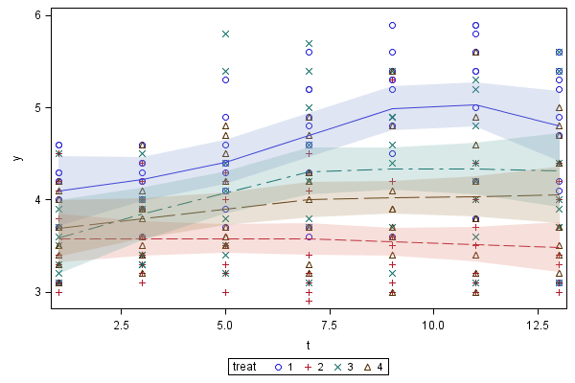

An easier type of plot to make is this

proc sgpanel data=repeated;
panelby treat;
series x=t y=y /group=dog;
run;
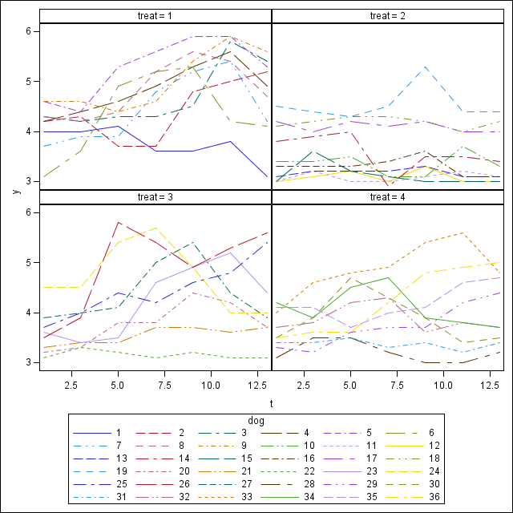

We see that the variance in time points 1 and 2 is smaller than the variance in later time points. Differences in variance are accounted for in the UN structure, but not in the AR(1) structure. A good choice of model might be a ARH(1) model that gives us both the advantage of estimating a single correlation coefficient and let the variances in different time points be different. The AIC for the ARH(1) model is the lowest of all three models.

Time as continuous or class variable

The time development does not look very linear (check the plots above), at least for one of the treatments. To use a linear time relationship might not be meaningful in this case but a quadratic relationship would be possible. If we want to do so, we exclude t from the class list and create a variable that can represent the quadratic term:

data repeated1;
set repeated;
t2=t*t;

ods graphics;
proc mixed data=repeated1 plots=(all);
class treat dog ;
model y=treat t t2 /ddfm=kr;
repeated /subject=dog type=arh(1);
run;

We get very similar fits using time as class variable and using a quadratic fit for time (the quadratic fit is worse, interactions between treatment and time are not significant). We leave this approach and continue with time as class variable.

Comparing the 4 treatments

To answer our question about differences between treatments we can compute LSMeans and make pairwise comparisons. We also choose to adjust for multiple testing using Tukeys method.

proc mixed data=repeated;
class treat dog t;
model y=treat t treat*t;
repeated /subject=dog type=arh(1);
lsmeans treat*t /pdiff adjust=tukey;
run;

The result is very hard to overview and many of the p-values are very high. There are some significant differences, e.g. if we compare treatment 1 time point 9 with treatment 4 time point 1, but this is of course completely irrelevant. We notice that we have too much output and that we overcorrect using SAS Tukey method in this case, since it corrects for nearly 400 comparisons out of which very many are not interesting.

We start by trying to get an overview using letter grouping. This is not implemented in PROC MIXED but we can use a SAS macro that is available on: http://www.stat.lsu.edu/faculty/geaghan/pdmix800.sas.txt .
First we need to complete our mixed program with an ods output step to save estimated differences and lsmeans to new dataset:

proc mixed data=repeated plots=(all);
class treat dog t;
model y=treat t treat*t;
repeated /subject=dog type=arh(1);
lsmeans treat*t/pdiff adjust=tukey ;
ods output diffs=diffs lsmeans=lsm;
run;

Then you can copy the code of the macro into the editor and run it or, better, save it to a file and call the file from SAS by (remember to change the path):
%include 'Z:\my documents\pdmix800_sas.txt';

Now we can run the macro by:
%pdmix800(diffs,lsm,sort=yes);

and get:

Obs | treat | t | Estimate | Standard Error | Letter Group
1 | 1 | 11 | 5.2222 | 0.2367 | A
2 | 1 | 9 | 5.0667 | 0.2423 | AB
3 | 1 | 13 | 4.7222 | 0.2291 | BC
4 | 1 | 7 | 4.6556 | 0.2392 | CD
5 | 3 | 9 | 4.5000 | 0.2570 | BCDE
6 | 3 | 7 | 4.4375 | 0.2537 | BCDE
7 | 1 | 5 | 4.4000 | 0.2330 | CDE
8 | 3 | 11 | 4.3250 | 0.2510 | CDEF
9 | 3 | 13 | 4.2250 | 0.2430 | CDEFG
10 | 3 | 5 | 4.2000 | 0.2472 | CDEFGH
11 | 1 | 3 | 4.1778 | 0.1454 | EF
12 | 1 | 1 | 4.1111 | 0.1578 | EFGI
13 | 4 | 7 | 4.0667 | 0.2392 | DEFGIJ
14 | 4 | 11 | 4.0556 | 0.2367 | DEFGHIJ
15 | 4 | 13 | 4.0444 | 0.2291 | DEFGHIJ
16 | 4 | 5 | 4.0111 | 0.2330 | DEFGIJ
17 | 4 | 9 | 3.9778 | 0.2423 | EFGHIJ
18 | 4 | 3 | 3.7778 | 0.1454 | FGHIJ
19 | 3 | 3 | 3.7250 | 0.1542 | IJK
20 | 2 | 9 | 3.6600 | 0.2299 | FGHIJ
21 | 4 | 1 | 3.6444 | 0.1578 | HK
22 | 2 | 3 | 3.6300 | 0.1379 | JK
23 | 2 | 5 | 3.6200 | 0.2211 | GHIJ
24 | 3 | 1 | 3.6000 | 0.1673 | JK
25 | 2 | 1 | 3.5400 | 0.1497 | JK
26 | 2 | 11 | 3.5000 | 0.2245 | JK
27 | 2 | 7 | 3.4600 | 0.2269 | JK
28 | 2 | 13 | 3.4600 | 0.2174 | JK
This is of course also hard to overview and of more use if look at main factors but it gives at least some sorting and a feeling about where the significant differences lie.

Another possibility is to extract the interesting comparisons and compare them using a simple Bonferroni adjustment. We start by extracting the comparisons between the different treatments at the same time point. First we save all comparisons in a new file called diffs (you have already done that above, but here is the program once more):

proc mixed data=repeated;
class treat dog t;
model y=treat t treat*t;
repeated /subject=dog type=arh(1);
lsmeans treat*t /pdiff ;
ods output diffs=diffs;
run;

We select the comparisons that are relevant, in this case if treat has differernt values but t has the same.

data diffs1;
set diffs;
if treat ne _treat & t = _t;
run;

We look at the differences and check if they are significant at a significance level adjusted with Bonferronis method: We make 42 relevant comparisons and compute the new significance level to 0.05/42=0.0012. We find significant difference mainly between treatment 1 and 2 (at time point 7 and later)

proc print data=diffs1;
run;

Obs | Effect | treat | t | _treat | _t | Estimate | StdErr | DF | tValue | Probt
1 | treat*t | 1 | 1 | 2 | 1 | 0.5711 | 0.2175 | 192 | 2.63 | 0.0093
2 | treat*t | 1 | 1 | 3 | 1 | 0.5111 | 0.2300 | 192 | 2.22 | 0.0274
3 | treat*t | 1 | 1 | 4 | 1 | 0.4667 | 0.2231 | 192 | 2.09 | 0.0378
4 | treat*t | 1 | 3 | 2 | 3 | 0.5478 | 0.2004 | 192 | 2.73 | 0.0068
5 | treat*t | 1 | 3 | 3 | 3 | 0.4528 | 0.2119 | 192 | 2.14 | 0.0339
6 | treat*t | 1 | 3 | 4 | 3 | 0.4000 | 0.2056 | 192 | 1.95 | 0.0531
7 | treat*t | 1 | 5 | 2 | 5 | 0.7800 | 0.3212 | 192 | 2.43 | 0.0161
8 | treat*t | 1 | 5 | 3 | 5 | 0.2000 | 0.3397 | 192 | 0.59 | 0.5567
9 | treat*t | 1 | 5 | 4 | 5 | 0.3889 | 0.3296 | 192 | 1.18 | 0.2394
10 | treat*t | 1 | 7 | 2 | 7 | 1.1956 | 0.3297 | 192 | 3.63 | 0.0004
11 | treat*t | 1 | 7 | 3 | 7 | 0.2181 | 0.3487 | 192 | 0.63 | 0.5325
12 | treat*t | 1 | 7 | 4 | 7 | 0.5889 | 0.3383 | 192 | 1.74 | 0.0833
13 | treat*t | 1 | 9 | 2 | 9 | 1.4067 | 0.3340 | 192 | 4.21 | <.0001
14 | treat*t | 1 | 9 | 3 | 9 | 0.5667 | 0.3533 | 192 | 1.60 | 0.1103
15 | treat*t | 1 | 9 | 4 | 9 | 1.0889 | 0.3427 | 192 | 3.18 | 0.0017
16 | treat*t | 1 | 11 | 2 | 11 | 1.7222 | 0.3262 | 192 | 5.28 | <.0001
17 | treat*t | 1 | 11 | 3 | 11 | 0.8972 | 0.3450 | 192 | 2.60 | 0.0100
18 | treat*t | 1 | 11 | 4 | 11 | 1.1667 | 0.3347 | 192 | 3.49 | 0.0006
19 | treat*t | 1 | 13 | 2 | 13 | 1.2622 | 0.3159 | 192 | 4.00 | <.0001
20 | treat*t | 1 | 13 | 3 | 13 | 0.4972 | 0.3340 | 192 | 1.49 | 0.1383
21 | treat*t | 1 | 13 | 4 | 13 | 0.6778 | 0.3241 | 192 | 2.09 | 0.0378
22 | treat*t | 2 | 1 | 3 | 1 | -0.06000 | 0.2245 | 192 | -0.27 | 0.7896
23 | treat*t | 2 | 1 | 4 | 1 | -0.1044 | 0.2175 | 192 | -0.48 | 0.6316
24 | treat*t | 2 | 3 | 3 | 3 | -0.09500 | 0.2069 | 192 | -0.46 | 0.6466
25 | treat*t | 2 | 3 | 4 | 3 | -0.1478 | 0.2004 | 192 | -0.74 | 0.4617
26 | treat*t | 2 | 5 | 3 | 5 | -0.5800 | 0.3316 | 192 | -1.75 | 0.0819
27 | treat*t | 2 | 5 | 4 | 5 | -0.3911 | 0.3212 | 192 | -1.22 | 0.2249
28 | treat*t | 2 | 7 | 3 | 7 | -0.9775 | 0.3404 | 192 | -2.87 | 0.0045
29 | treat*t | 2 | 7 | 4 | 7 | -0.6067 | 0.3297 | 192 | -1.84 | 0.0673
30 | treat*t | 2 | 9 | 3 | 9 | -0.8400 | 0.3448 | 192 | -2.44 | 0.0158
31 | treat*t | 2 | 9 | 4 | 9 | -0.3178 | 0.3340 | 192 | -0.95 | 0.3426
32 | treat*t | 2 | 11 | 3 | 11 | -0.8250 | 0.3368 | 192 | -2.45 | 0.0152
33 | treat*t | 2 | 11 | 4 | 11 | -0.5556 | 0.3262 | 192 | -1.70 | 0.0902
34 | treat*t | 2 | 13 | 3 | 13 | -0.7650 | 0.3261 | 192 | -2.35 | 0.0200
35 | treat*t | 2 | 13 | 4 | 13 | -0.5844 | 0.3159 | 192 | -1.85 | 0.0658
36 | treat*t | 3 | 1 | 4 | 1 | -0.04444 | 0.2300 | 192 | -0.19 | 0.8470
37 | treat*t | 3 | 3 | 4 | 3 | -0.05278 | 0.2119 | 192 | -0.25 | 0.8036
38 | treat*t | 3 | 5 | 4 | 5 | 0.1889 | 0.3397 | 192 | 0.56 | 0.5788
39 | treat*t | 3 | 7 | 4 | 7 | 0.3708 | 0.3487 | 192 | 1.06 | 0.2889
40 | treat*t | 3 | 9 | 4 | 9 | 0.5222 | 0.3533 | 192 | 1.48 | 0.1410
41 | treat*t | 3 | 11 | 4 | 11 | 0.2694 | 0.3450 | 192 | 0.78 | 0.4358
42 | treat*t | 3 | 13 | 4 | 13 | 0.1806 | 0.3340 | 192 | 0.54 | 0.5895

Appendix:

Program to create the picture giving a mean function per treatment:

proc sort data=repeated;
by treat t;

proc loess data=repeated;
by treat;
model y = t / clm;
score /clm;
ods output ScoreResults=SR;
run;

proc sgplot data=SR;
scatter x=t y=y / group=treat;
series x=t y=p_y / group=treat;
band x=t lower=lcl_y upper=ucl_y / group=treat transparency=0.75;
run;

