GS-VMAS Newsletter
February, 2022
GS-VMAS are happy to announce that we now have a four year plan (2022 – 2025) for recurring courses that are given every year and every second year and we hope that this will help supervisors and students better plan the studies. Apart from the 16 PhD courses that will be arranged during 2022 we are also planning several seminars and workshops for both PhD students and supervisors. These include, a half-day seminar on different aspects related to publishing, seminars regarding different careers paths as well as a workshop for supervisors on Academic productivity. More workshops and seminars will come during the year and remember that you are always welcome to contact us at GS-VMAS if you have any topic suggestions.
Upcoming seminars and workshops spring 2022
Seminar on scientific publishing
March 22, 13.00-16.00
GS-VMAS will give a half-day seminar on scientific publishing. Topics that will be covered:
- Selection of the Scientific Journal
- The Vancouver Recommendations
- Communication with the journal
- Journal Ranking and Impact
More information about the workshop and how to register will be announced by separate email as well as on GS-VMAS homepage GS-VMAS Planned activities | Externwebben (slu.se).
Career after PhD studies
March 30, 12.30-13.00
Interested in a career outside of Academia? Welcome to listen to Karl Ståhl who will describe his career journey from being a PhD student at the VH-faculty to where is today.
Karl Ståhl is the State epizootiologist and Head of the Department of disease control and epidemiology at the National Veterinary Institute (SVA). He received a degree in Veterinary Medicine from SLU in 1998, and a Ph.D. in veterinary virology from the same university in 2006.
More information about the workshop and how to register will be announced by separate email as well as on GS-VMAS homepage GS-VMAS Planned activities | Externwebben (slu.se).
Workshop on Academic productivity for supervisors
May 3, 9.00-12.00
On the 3rd of May (at 9.00-12.00) GS-VMAS will organize a workshop on Academic productivity for all those at the VH-faculty that supervise PhD/resident students. The aim of the workshop is to provide productivity tools and strategies that can be applied to your own work situation as well as to your supervision of graduate students.
More information about the workshop and how to register will be announced by separate email as well as on GS-VMAS homepage, but please already now save the date if you are interested in attending. The workshop will take place over Zoom.
Planned courses 2022
For 2022 we have the following planned courses:
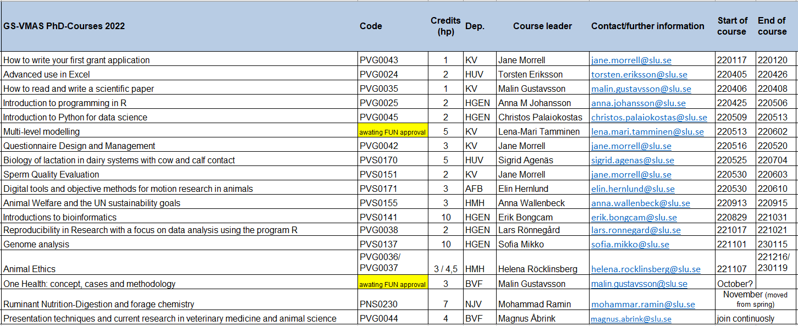
More information will be updated at the web www.slu.se/gs-vmas-planned-courses.
Presentation technique course at the VH Faculty
The course can be joined continuously by visiting https://slu-se.instructure.com/courses/1809 and clicking “Join the course” and logging in with your SLU account.
The course will include different workshops related to research presentation techniques - both to a scientific and a non-scientific audience. In addition, research students will also have practical training in giving seminars through presenting at the VH-faculty seminar series.
For more information, please visit: VH Presentation technique course | Externwebben (slu.se)
Upcoming PhD courses spring 2022
During spring 2022 we have the following upcoming courses:

PVG0024 Advanced use in Excel
Credits: 2
Course dates: 220405-220426 (scheduled course days: April 5, April 12, April 26)
Course poster
Course syllabus
Application to course

PVG0035 How to read and write a scientific paper
Credits: 1
Course dates: 220406-220408
Course poster
Course syllabus
Application to course

PVG0025 Introduction to programming in R
Credits: 2
Course dates: 220425-220506
Course poster
Course syllabus
Application to course

PVG0045 Introduction to Python for data science
Credits: 2
Course dates: 220509-220513
Course poster
Course syllabus
Application to course

PVSXXX Multi-level modelling
Credits: 5
Course dates: 220513-220502
Course poster
Course syllabus
Application to course

PVG0042 Questionnaire Design and Management
Credits: 3
Course dates: 220516-220520
Course poster
Course syllabus
Application to course

PVS0170 Biology of lactation in dairy systems with cow and calf contact
Credits: 5
Course dates: 220525-220704 Block 1: 220525-220610 (distance, 50%) Block 2: 220613-220617 (campus, 100%) Block 3: 220620-220704 (distance, 50%)
Course poster
Course syllabus
Application to course

PVS0151 Sperm Quality Evaluation
Credits: 2
Course dates: 220530-220603
Course poster
Course syllabus
Application to course

PVS0171 Digital tools and objective methods for motion research in animals
Credits: 3
Course dates: 220530-220610
Course poster
Course syllabus
Application to course
SLU's general courses for PhD students
For more information regarding SLU's general courses in transferable skills, please visit the SLU webpage on Doctoral courses.
Do you have an idea for a seminar or a workshop?
GS-VMAS have funds available to grant money for seminars and/or workshops. If you have a visiting research partner or an opponent present for a dissertation it may be a great opportunity to combine this with arranging a seminar or workshop.
Please contact us at gs-vmas@slu.se and we will let you know whether there are funds available for your idea.

Administration of your PhD studies
If you have any questions regarding the administration of your PhD studies, such as registration, crediting for courses, all courses completed in Ladok, you may use Education Services’ joint e-mail address for PhD matters: us-phd-vh@slu.se
All the best from the coordinators and administrators for GS-VMAS
Miia, Anne-Lie, Göran and Susanna

