

**GS-VMAS Newsletter**

September, 2023

*Our first call for PhD-courses 2024 is finished and we are happy to announce that so far 16 courses are planned for 2024 but we hope to provide even more courses as we have now opened the second call (deadline 15th Nov). For this fall semester, we are planning activities for both PhD students and supervisors such as a seminar about possible career opportunities outside of academia and a seminar on Research ethic/misconduct. Also don’t forget that we are accepting mobility applications from PhD- and resident students attending courses at either Swedish universities or universities in other countries (see our webpage for further details).*

**Planned courses 2024**

For 2024 we have, so far, the following planned courses:

|  |  |  |  |  |
| --- | --- | --- | --- | --- |
| **GS-VMAS PhD-Courses 2024** | **Code** | **Credits (hp)** | **Dep.** | **Course leader** |
| Advanced use in Excel | PGV024 | 2 | HUV | Torsten Eriksson |
| Introduction to programming in R | PVG0025 | 2 | HGEN | Anna M Johansson |
| How to write your first grant application | PVG0043 | 1 | KV | Jane Morell |
| Biology of Genomes | P000043 | 7,5 | HGEN | Sofia Mikko |
| Analysis of Genomes | P000042 | 7,5 | HGEN | Sofia Mikko |
| Introduction to bioinformatics | PVS0141 | 10 | HGEN | Samuel Coulbourn Flores |
| Presentation techniques and current research in veterinary medicine and animal science | PVG0044 | 4 | BVF | Magnus Åbrink |
| Animal Welfare and the UN sustainability goals | PVS0155 | 3 | HMH | Anna Wallenbeck |
| Animal Ethics | PVG0036/ PVG0037 | 3 / 4,5 | HMH | Helena Röcklinsberg |
| Animal personalities |  | 3 (or 2) | AFB | Svante Winberg/Erika Roman |
| Comparative Reproductive Biotechnologies | PVS0163 | 2 | KV | Ylva Sjunnesson |
| Introduction to programming in Matlab |  | 3 | AFB | Ylva Mellbin |
| Introduction to Python for data science | PVG0045 | 2 | HGEN | Christos Palaiokostas |
| One Health: concept, cases and methodology | PVG0047 | 4 | BVF | Elisabeth Rajala |
| Reproducibility in Research with a focus on data analysis using the program R | PVG0038 | 2 | HGEN | Lars Rönnegård |
| Grazing and herbivory with focus on domestic ruminants and semi wild herbivores | P000017 | 3 | AFB | Mårten Hetta, Horacio Gonda och Carl-Gustaf Thulin |

During the autumn there will be a 2nd call for interest to arrange a PhD course during 2024, so there will be courses added to this list after that.

**2nd call for organising a GS-VMAS PhD course in 2024**

It is now time for our 2nd call for organizing GS-VMAS PhD courses 2024 and we are therefore keen to hear which PhD-courses you would like to organize next year. We need to receive your suggestions no later than November 15th.

If you wish to organize a course please attach a notice of interest, a budget and an estimation of the number of post-graduate students who are potentially interested to attend according to the instructions at GS-VMAS homepage: [www.slu.se/gs-vmas-guide-course-organiser](http://www.slu.se/gs-vmas-guide-course-organiser).

**Upcoming PhD courses autumn 2023**

There are still three courses open for admission during the autumn:

* PVS0141 - Introduction to bioinformatics, 10 credits
* P000052/P000054 - Machine Learning in Agricultural Bioinformatics, 5 or 3 credits
* PVS0171 - Digital tools and objective methods for motion research in animals, 3 credits

For more information and on-line application to courses, please visit: <https://www.slu.se/en/graduate-schools/graduate-school-veterinary-medicine-and-animal-sciences/gs-vmas-courses-and-application/>

**Seminars and workshops autumn 2023**

This autumn we are planning a new seminar about possible careers outside of academia. One of the two speakers is Sofia Malm, who 2010 defended her PhD thesis at HGEN. She holds a position as geneticist at the Swedish Kennel Club. Further information including the second speaker, date and a link to sign up to the seminar will soon come by email. We are also planning a seminar/workshop on ethics in research and research misconduct aimed at both PhD students and supervisors. More information about this will come soon.

**Presentation technique course at the VH Faculty**

The VH-faculty has since 2020 given a seminar and presentation technique course, with Magnus Åbrink from BVF as course leader. The course can be joined continuously by visiting <https://slu-se.instructure.com/courses/1809> and clicking “Join the course” and logging in with your SLU account.

The course includes different workshops related to research presentation techniques - both to a scientific and a non-scientific audience. In addition, PhD students will also have practical training in giving seminars through by presenting their research at the VH-faculty seminar series.

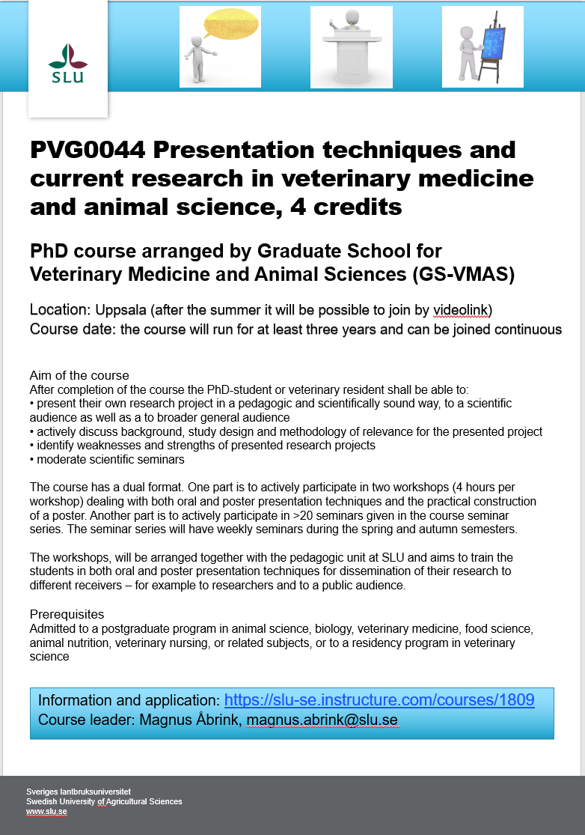

**SLU's general courses for PhD students**

For more information regarding SLU's general courses in transferable skills, please visit the [SLU webpage on Doctoral courses](https://internt.slu.se/en/support-services/education/doctoral-education1/doctoral-courses/).

**Do you have an idea for a seminar or a workshop?**

GS-VMAS has funds available to grant money for seminars and/or workshops. If you have a visiting research partner or an opponent present for a dissertation it may be a great opportunity to combine this with arranging a seminar or workshop.

Please contact us at [gs-vmas@slu.se](mailto:gs-vmas@slu.se) and we will let you know whether there are funds available for your idea.

## **Administration of your PhD studies**

If you have any questions regarding the administration of your PhD studies, such as registration, crediting for courses, all courses completed in Ladok, you may use Education Services’ joint e-mail address for PhD matters: [us-phd-vh@slu.se](mailto:us-phd-vh@slu.se)

*All the best from the GS-VMAS coordinators*

*Miia, Anne-Lie and Göran*