168th EAAE Seminar
“Behavioural Perspectives in Agricultural Economics and Management”

6-7 February, 2019, Uppsala, Sweden
Paper Preparation – Author and Submission Guidelines

Participants who would like to present their paper/poster at the seminar should submit their extended abstracts (less than 500 words, maximum two pages for oral presentations; one page for posters) by 15 October 2018 to EAAE-seminar-SLU2019@slu.se. Please indicate one corresponding author.

Full papers are due on 15 January 2019. An abstract of no more than 100 words should precede the paper, stating the objectives, methods, results, and main conclusions. Please also include up to five keywords.

Formatting full papers: 2.5 cm margins on all pages; justified text in Times New Roman 12 point font, single spacing; no underlining; all headings left justified; all headings in 12 point TNR; level one headings in bold, level two headings in bold, no level three headings; consecutive page numbers; all papers should use the template title page (see below); integrate figures and tables in the text.
Figure titles should be below the figure, left justified; table titles should be above the table. Please include sources. Use the equation editor for equations. Use double space between text and equations, and centre equations. Number equations consecutively.

References: Please refer to the style of the European Review of Agricultural Economics. References are cited in the text with name and year of publication. For direct quotes, please use page numbers (Swinnen, 1997: 12) or (Zeller et al., 1997). More information is available at: http://www.oxfordjournals.org/our_journals/erae/for_authors/index.html.

Please submit your full papers as a PDF file to EAAE-seminar-SLU2019@slu.se. Papers will be uploaded to the AgEcon website. Please note that we will not edit papers. Authors take full responsibility for their own content.

TTLE PAGE TEMPLATE
(PLEASE FILL IN THE SPACES IN YELLOW AND SIMPLY DELETE THESE LINES IN RED)

Title of the Paper

AUTHORS
Affiliation
Institution
E-mail address

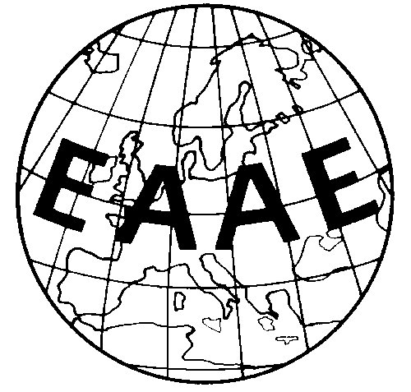

Paper prepared for presentation for the 168th EAAE Seminar
Behavioural Perspectives in Agricultural Economics and Management
February 6-7, 20189
Swedish University of Agricultural Sciences
Uppsala, Sweden

Copyright 2019 by AUTHORS. All rights reserved. Readers may make verbatim copies of this document for non-commercial purposes by any means, provided that this copyright notice appears on all such copies.

