VR Manual

What is the VR Manual?
We are creating a document explaining the basics of working with VR experiences in the NATUREACH project. It is primarily aimed at project staff, and not the clients and patients.
This is only a first draft of the manual and includes the chapters on how to prepare the VR headset for use. Some chapters are therefore still left empty.
We will update the manual to version 2.0 as soon as possible.

Chapters
Introduction 2
1 Preparing the VR Hardware 4
1.1 Unboxing and Setup 4
1.2 Headset Functionality 6
1.3 Controller Functionality 9
1.4 Disassembly 10
1.5 QuickStart 11
1.6 Using VR headset with eyeglasses 13
2 Preparing the VR software 14
2.1 Opening the Settings Menu 15
2.2 Connect to a Network 15
2.3 Update the System 15
2.4 IPD Adjustment (Automatic) 16
2.5 Enable Developer Settings 17
2.6 Disable Play Boundary 17
2.7 Quick IPD Adjustment 17
2.8 Check internal clock (date and time) 18
2.9 Set NATUREACH-application as Home Screen 18
3 Downloading and Installing the NATUREACH-application 18
3.1 Downloading the NATUREACH application 19
3.2 Option 1: Downloading the app using a computer + VR headset 19
3.3 Option 2: Downloading the app using only a VR headset 19
3.4 Install the NATUREACH-application 20
3.5 Initial Setup 23
4 Adding VR nature environments 24
4.1 Option 1: Downloading VR environments using a computer + VR headset 24
4.2 Option 2: Downloading VR environments using only a VR headset 25
4.3 Moving files using an external storage device 27
4.4 Troubleshooting for External Storage Devices 28
5 NATUREACH-application User Guide 29
5.1 Regular use 30
5.2 Configuration 32
5.3 Assisting a Patient with the NATUREACH-application 32
6 Physical Surroundings and Additional Equipment 32
7 Using VR with Clients 33
8 Screen Casting 34
9 Data Collection 38
10 Troubleshooting / FAQ 39
10.1 Missing Exit button 40
11 Maintenance 40
11.1 Hygienic Use of VR headset 41
11.2 Charging 41
11.3 Avoid exposing the VR headset lenses to direct sunlight 41
12 Contact Information 42

Introduction
This paragraph will be written after everything else.
Editor: TBD

Preparing the VR Hardware
Editor: Joni
This chapter will cover all the essential hardware features of the Pico 4 VR headset.

Unboxing and Setup
- Upon receiving your Pico 4 VR headset, ensure that the package includes the following: the headset itself, two controllers, glasses spacer, nose pad, USB-C Power Adapter, USB-C to C 2.0 Data Cable, two hand straps for the controllers, a user manual, a quick guide and a safety and warranty guide (see Figure 1).
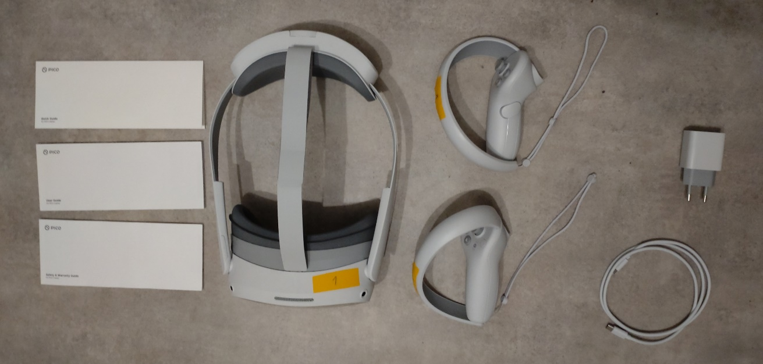
Figure 1 Pico 4 Unboxed
- Inspect each item for any damage incurred during shipping.
- Unpack and familiarize yourself with all the items included in the package.
- Charge the headset using the provided charging cable. The headset should have a battery life of approximately 3 hours.
- Install the batteries in the controllers and make sure they are charged (see Figure 2). The controllers use 1.5V AA alkaline batteries.
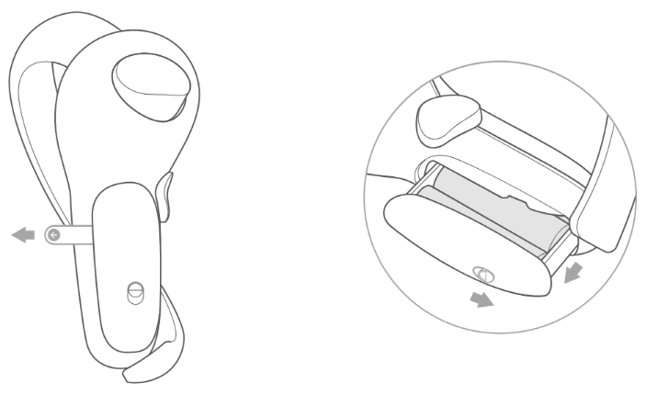
Figure 2 Batteries
- Attach the nose pad (see Figure 3).
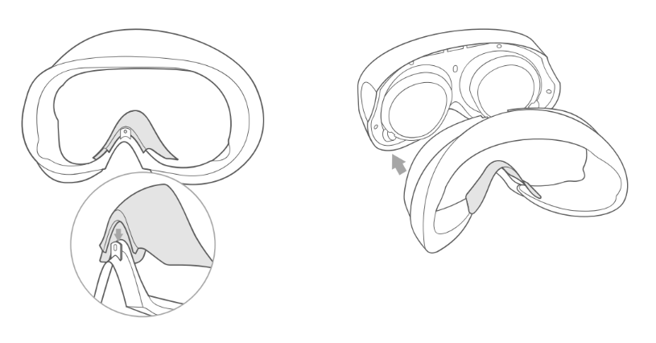
Figure 3 Nose Pad

- The glasses spacer should only be attached when the VR headset is used while wearing glasses (see Figure 4). The glasses spacer is attached via magnets and should stick firmly on the headset.
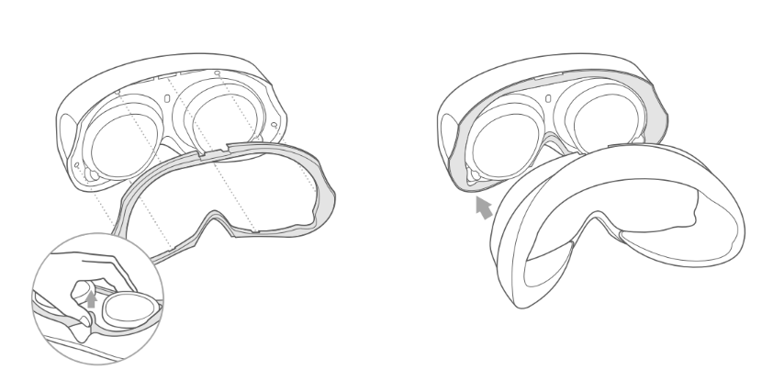
Figure 4 Glasses Spacer
- Attach the hand straps to the controllers (see Figure 5).
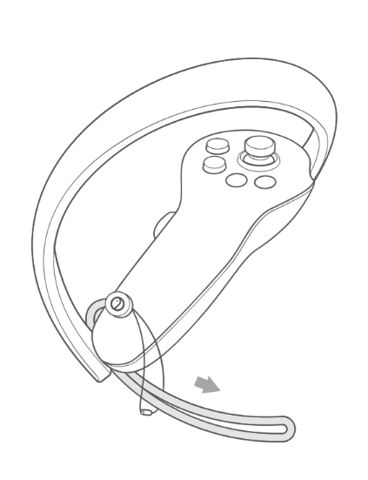
Figure 5 Hand Straps

Headset Functionality
The headset has the following key hardware features:
- Power button (see Figure 6 button 1).
  - Power on: Press for 2 or more seconds.
  - Power off: Press for 5 or more seconds.
  - Hardware reset: Press for 10 or more seconds.
- Status Indicator (see Figure 6 indicator 2).
  - Blue: Powered on with 20% or more battery left.
  - Red: Charging, battery is less than 20% full.
  - Yellow: Charging, battery is less than 98% full.
  - Green: Charging, battery is more than 98% full.
  - Blue flashing: Powering down.
  - Red flashing: Battery is less than 20% full.
  - No color: Sleeping or powered off.

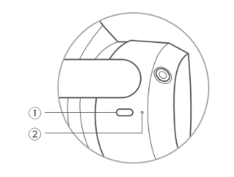
Figure 6 Power button and Headset Status Indicator

The headset has the following features: (see Figure 7).
- Face cushion.
- Volume buttons.
- RGB see-through camera.
- Top strap.
- Strap dial.
- Tracking cameras.
- USB-C interface.
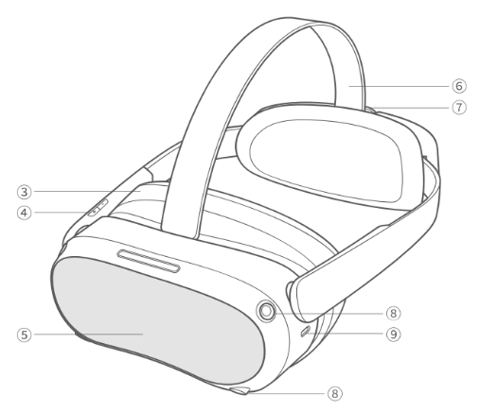
Figure 7 Headset Details

The head-mounted display consists of the following parts: (see Figure 8).
- Speakers.
- Proximity sensor.
- Eye tracking cameras.
- Face tracking camera.

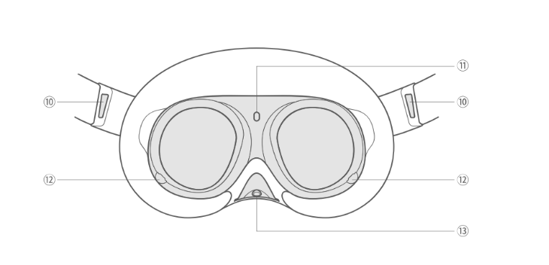
Figure 8 Head-Mounted Display

Controller Functionality
The controllers have the following buttons and functionalities: (see Figure 9 and Figure 10).
- Joystick, each controller’s joystick functions like a cursor. The position is indicated via a white laser and dot. The controller’s joysticks function separately and independently.
- Open the menu.
- Home.
  - Power on: Press and hold for 2 or more seconds.
  - Power off: Press and hold for 5 or more seconds.
  - Return home: Press.
  - Recenter the screen: Press and hold for 1 second.
- Status indicator.
  - Blue: Firmware updating in progress.
  - Flashing Blue: Searching for connection.
  - Flashing Red and Blue: Pairing in progress.
  - No color: Connected or powered off.
- Grip.
- Capture. The capture button can be used to take screenshots.

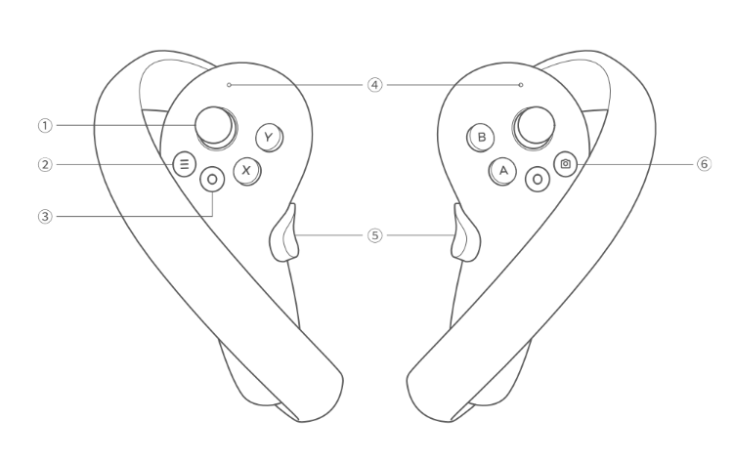
Figure 9 Controller Functionality
- Trigger. Used in conjunction with the joystick. You can use the trigger to select things.
- Battery case.
- Tracking ring.

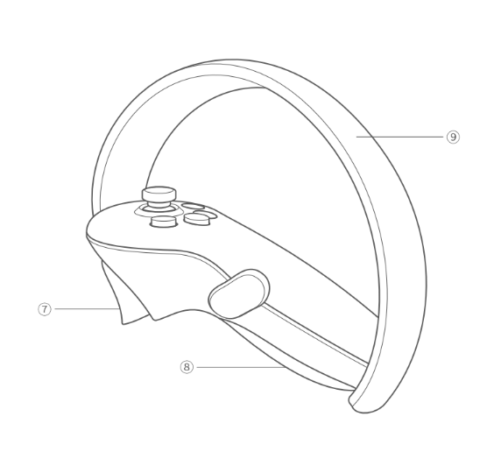
Figure 10 Controller Functionality 2

Disassembly
The headset can be disassembled in the following way: (see Figure 11). This is especially helpful when cleaning the headset.
- Detach the face cushion by gently pulling it backwards.
- Unhook the top strap by pulling it downwards and then pulling it backwards.
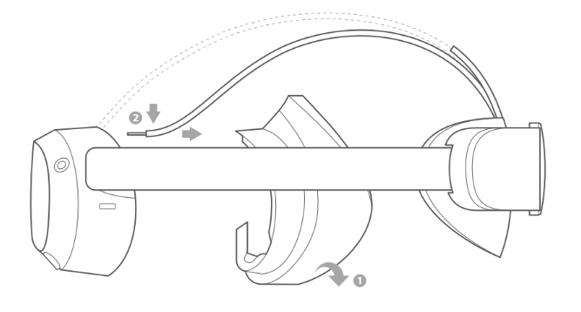
Figure 11 Disassembly

QuickStart
The headset can be used following these simple steps:
- Power on the controllers by pressing the home button for 2 or more seconds (see Figure 12). The controller should vibrate to indicate that it has been turned on. For more information see the section on Controller Functionality.

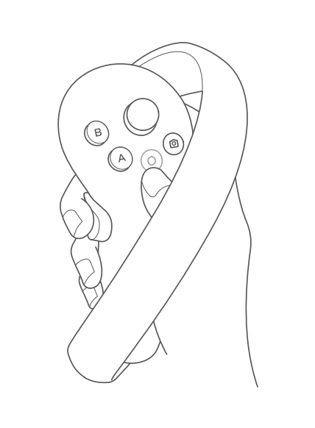
Figure 12 Power on Controllers

- Power on the headset by pressing the power button for 2 or more seconds (see Figure 13). The status indicator should turn blue to indicate that the headset has been turned on. For more information see the section on Headset Functionality.

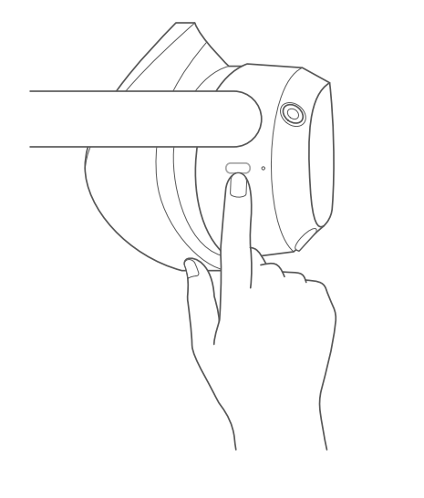
Figure 13 Power on Headset
- Release the top strap and turn the strap dial to adjust the headset for a comfortable fit (see Figure 14).

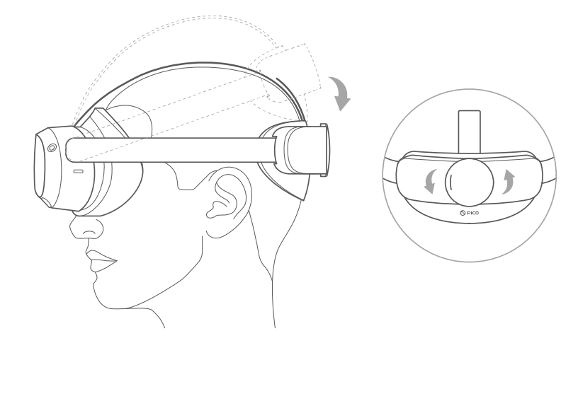
Figure 14 Adjust top strap and strap dial
- Ensure the headset fits snugly on your head without being too tight.
- Tighten the strap dial and fasten the top strap.
- Make sure the headset stays comfortably on your head.
- If the screen gets foggy during the VR experience, it means some air is getting through from your nose into the lens. Readjust the headset.
- The view should be very clear and sharp during the VR experience, if the view is not clear, readjust the headset again.
- The VR headset should primarily be used in a seated position. If the headset is used in a reclining position, a soft strap without a strap dial or a pillow that fits the headset should be used.

Using VR headset with eyeglasses
If you normally wear eyeglasses or contact lenses for nearsightedness in your day-to-day life, it’s likely best to also wear them when using the VR headset. The reason is that the VR headset has built in lenses that make the image appear to be further away, meaning that a nearsighted person might see a blurry image without eyeglasses or contact lenses.
By the same logic, if you typically wear reading glasses only when reading books etc. you probably won’t need them when using the VR headset even though the screen is physically very close to your eyes. Because of the built in lenses.
When using the VR headset with eyeglasses we recommend using the glasses spacer (see Figure 4)

Preparing the VR software
Editor: Joni, Martin
Follow the steps in this section in order, unless otherwise instructed. Following the steps discussed in this chapter is only necessary during the initial setup of the Pico 4 headset for use or during maintenance.

Opening the Settings Menu
The settings menu can be opened from the Pico starting screen (see Figure 15).
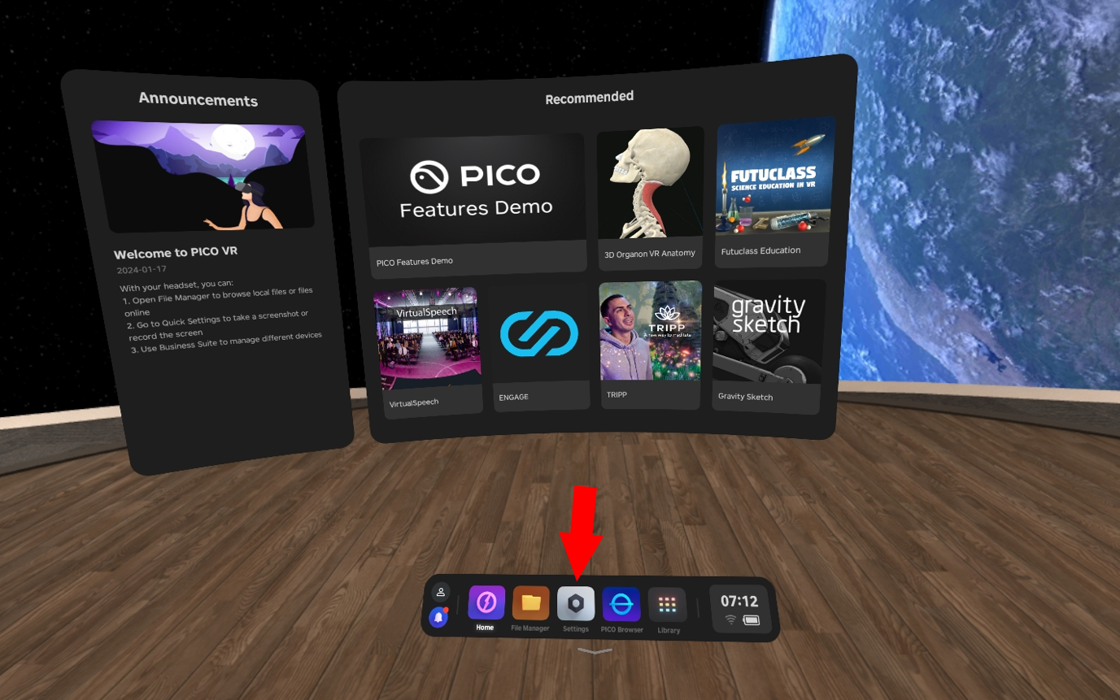
Figure 15 Pico 4 Settings

Connect to a Network
Connecting to a network is only necessary during screen casting, maintenance, when updating the system or downloading videos via the headset. During regular use the headset does not need to be connected to a network, unless you want to cast the VR headsets screen to an external device. To connect to a network, follow these steps:
- Open the Settings menu.
- Navigate to the WLAN tab.
- Connect to a Network.

Update the System
Updating the system is only necessary during the initial setup of the Pico 4 headset and periodically after that once you have been informed about a new system update. To update the system, follow these steps:
- Open the Settings menu.
- Navigate to the General tab.
- Open the system version tab.
- Make sure there are no updates, and the system is up to date.

IPD Adjustment (Automatic)
IPD stands for “Interpupillary distance” and doing an IPD adjustment calibrates the headset to match the distance between the pupils of the person wearing the headset. This is important since an incorrect IPD setting can lead to unnecessary eye strain and a worse looking image. The calibration can be done manually but we recommend that you turn on the automatic IPD adjustment to make it easier and faster.
Enabling the automatic IPD adjustment only needs to be done once, at the initial stage of setting up the Pico 4 headset for use. To do that, follow these steps:
- Open the Settings menu.
- Navigate to the Display tab.
- Select the IPD Adjustment option.
- Turn on Automatic IPD Adjustment.

Once enabled, the IPD adjustment will turn on automatically if the IPD between the previous user and the new user are different enough to affect the viewing experience. The automatic IPD adjustment requires the user to look at a rotating green dot (see Figure 16). The calibration is accompanied with audible English instructions.

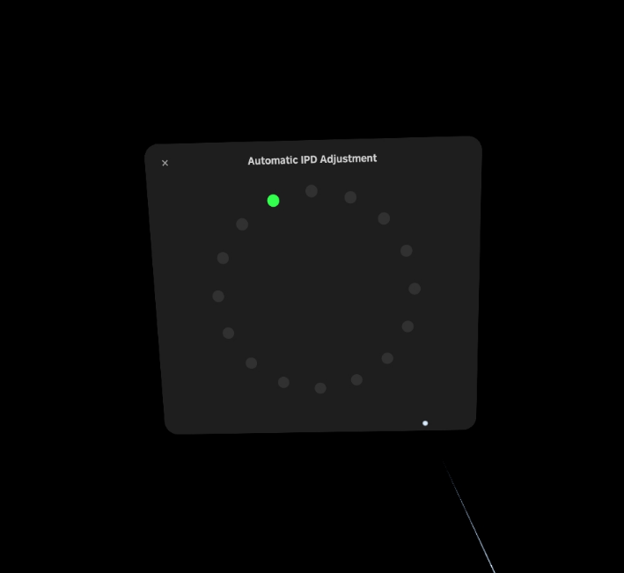
Figure 16 Automatic IPD Adjustment

Enable Developer Settings
This step only needs to be taken at the initial stage of setting up the Pico 4 headset for use. The developer settings can be disabled the same way as they are enabled. During regular use the developer settings can be disabled.
- Open the Settings menu.
- Navigate to the General tab.
- Select the About option.
- Navigate to the Software Version option and click it 7 times.
- The developer settings should now be enabled.

Disable Play Boundary
This step only needs to be taken at the initial stage of setting up the Pico 4 headset for use. The system asks you to confirm that you have read the displayed warning when turning off the play boundary. Please read the warning carefully and remember to inform the users that the play boundary has been turned off.
- Open the Settings menu.
- Navigate to the Developer tab.
- Turn off the Play Boundary option.

Quick IPD Adjustment
This step only needs to be taken at the initial stage of setting up the Pico 4 headset for use.
- Open the Settings menu.
- Navigate to the Developer tab.
- Select the Business Settings option.
- Navigate to the General tab.
- Navigate to the Quick IPD Measurement option and turn it on.

Check internal clock (date and time)
The internal clock is set automatically by default. But just to be on the safe side, it’s good to check the date and time before using it for the first time and after changing to winter- and summertime or when changing time zones (after a trip to Finland/Sweden for example). If the date and time are incorrect you can follow these steps to set it manually.
- Open the setting menu.
- Navigate to the general tab.
- Select the Date and Time option.
- Click on the Auto option. It should now be unselected.
- Set the date and time manually.
- Click on the Auto option again. It should now be selected.

Set NATUREACH-application as Home Screen
This step only needs to be taken at the initial stage of setting up the Pico 4 headset for use. Make sure you have read and completed the chapter on Downloading and Installing the NATUREACH-application before attempting this step. Setting the NATUREACH-application as the home screen makes using the VR headset easier for the patients. When the NATUREACH-application is set as the home screen the application automatically opens when you power on the headset. This removes the end users need to start the application each time and to learn how the Pico menus work. However, setting this option does make it harder to do anything else with the headset besides using the NATUREACH-application. We recommend you do this step last after having read and completed the rest of the chapters in this VR Manual.
- Open the Settings menu.
- Navigate to the Developer tab.
- Select the Business Settings option.
- Navigate to the Home Screen tab.
- Select the NATUREACH360-application.
- You should get a pop-up about restarting the VR headset. Select Restart Now.

After the home screen has been switched to the NATUREACH-application it can be changed back to the regular Pico home screen by following the steps above and selecting the PICO Launcher option.
Note: If the home button on the hand controller stops working after changing home screen, restart the headset and it should start working again.

Downloading and Installing the NATUREACH-application
Editor: Joni, Martin
This chapter will cover downloading and installing the NATUREACH-application.

Downloading the NATUREACH application
Before you can install the NATUREACH application you first need to download the installation file. You can either download the installation file directly to the VR headset using the built-in web browser or download it first to a computer and then transfer it from the computer to the headset.

Option 1: Downloading the app using a computer + VR headset
- Open a web browser on your computer and go to this website: www.t.ly/FbdSc
This is a OneDrive folder called “NATUREACH downloads”. It contains all the files you need. You might be asked to log in using your Microsoft365-account.
- Open the folder called “NATUREACH-app installation files” and download the content inside.
- Connect the VR headset to the computer with a USB-C cable.
- If you are using a PC, the VR headset will automatically show up as a new device on the computer called ”PICO 4 Enterprise”. If you are using a Mac, you first need to download software that allows the computer to connect to Android devices. You can find it here:

https://www.android.com/filetransfer/
When you have located the device, open it, and navigate to the following folder:
PICO 4 Enterprise > Internal shared storage > Download
Copy the downloaded installation file to this folder and safely eject the device.

- If you have more than one VR headset, simply plug in the next headset and copy the same file to the same folder on that device.

Option 2: Downloading the app using only a VR headset
- Put on the VR headset and connect it to the internet using Wi-Fi (for more information see the chapter titled Connect to a Network).
Open the Pico browser and go to this website: www.t.ly/FbdSc (see Figure 17 and Figure 18).
This is a OneDrive folder called “NATUREACH downloads”. It contains all the files you need. You might be asked to log in using your Microsoft365-account.
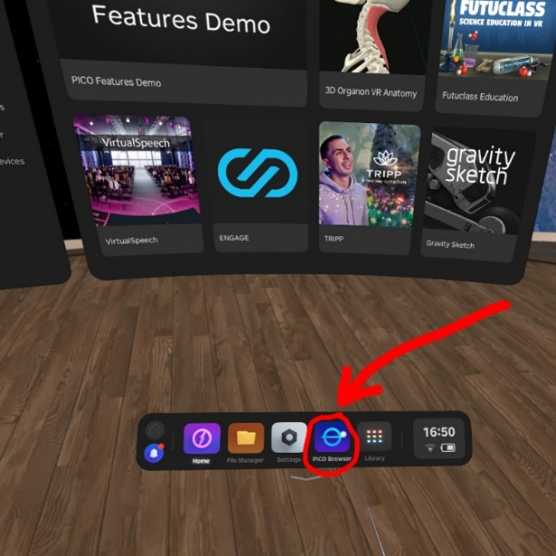
Figure 17 Pico Browser
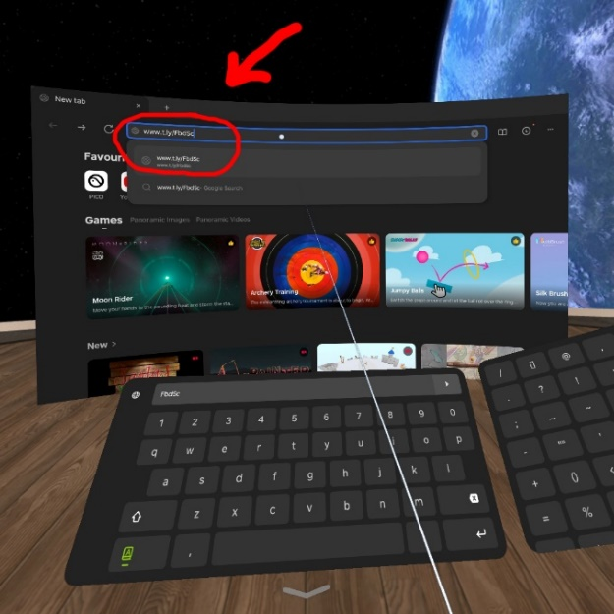
Figure 18 Pico Browser Search bar

- Open the folder called “NATUREACH-app installation files” and download the content inside.
- If you have more than one VR headset, repeat this process on the other headsets.

Install the NATUREACH-application
Once you have downloaded the application, installing the application is accomplished following these steps:
- Navigate to the file manager on your VR headset.
- Navigate to the APKs tab (see Figure 19).

Figure 19 Pico 4 APKs Tab

- Select the NATUREACH360 file.
- Select the option to install the application (see Figure 20).

Figure 20 Install NATUREACH-application

- You should get a pop-up once the installation has finished (see Figure 21).

Figure 21 NATUREACH-application Installed Pop-up
Once the installation is complete you should see the NATUREACH-application in the library menu.

Initial Setup
Once you have installed the NATUREACH-application on the VR headset, you need to do the initial setup, which requires you to check the applications settings and configure it to your particular needs. To configure the NATUREACH-application for regular use, follow these steps:
- Navigate to the Library menu on your headset.
- In the library you should see an application named NATUREACH360. Open the application.
- Wait until the NATUREACH and Interreg Aurora logos disappear.
- The application should then ask you to allow it to access eye tracking. Click allow.
- This should open the application’s settings menu (see Figure 22).

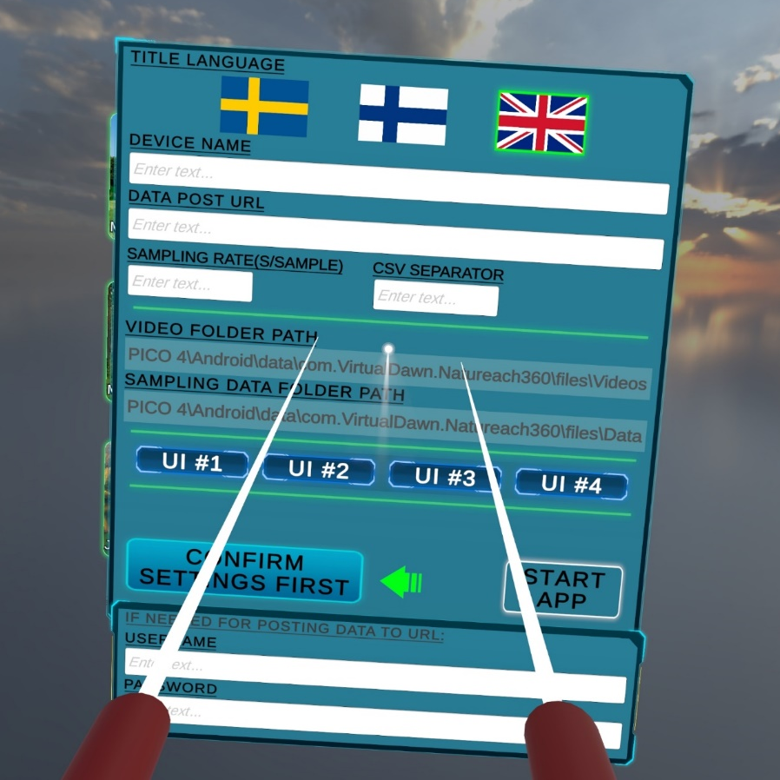
Figure 22 NATUREACH-application Settings Menu

The settings menu can be used via eye tracking and controllers. To configure the application, follow these steps:
- In the top row choose the language.
- Select UI #1.
- Select confirm settings first.
- Select start app.

This should open the application’s standard view, which is the same view that opens after you start the application going forward.
The settings can be changed later if necessary (see the section on Configuration if you want to change the settings).

Adding VR nature environments
Editor: Martin
Before you can view any virtual nature environments in the NATUREACH-application you first need to download the right video files from the internet if you do not already have them saved locally. Then you need to put them in the correct folder inside the VR headset. Make sure you have completed ALL the steps discussed in the chapter on Downloading and Installing the NATUREACH-application before going forward.
You can use the same two methods for downloading as you did with the app, but there are some more things to keep in mind since the files are much bigger and also need to be put in a specific folder.

Option 1: Downloading VR environments using a computer + VR headset
This is the best option if you are using many headsets and have access to a computer. This is how you do it:
- Open a web browser on your computer and go to this website: www.t.ly/FbdSc
This is a OneDrive folder called “NATUREACH downloads”. It contains all the files you need. You might be asked to log in using your Microsoft365-account.
- Open the folder called “VR environment files” and download all the video files (.mp4) you want + the small image files (.jpg) with the same name. It is important to always have both the video file and the image file of the same scene.
Also download the file called “localisation.csv”, which contains the language information and translations for all the video titles.
The mp4-files are quite large (around 15GB each) so make sure you have enough space on your computer to store them. Long download times are normal for these file sizes. Please take this into account when you plan your work. A fast internet connection is recommended.
- When all the files are downloaded, plug in the VR headset in the computer using the USB-cable that comes with the headset. If your computer doesn’t have a USB-C port, you can pick another USB-cable that fits your computer. For fast transfer speeds, make sure both your computer and cable use at least USB 3.0. (This is often, but not always, indicated by a blue color inside the connector and port).
- If you are using a PC, the VR headset will automatically show up as a new device on the computer called ”PICO 4 Enterprise”. If you are using a mac, you first need to download software that lets the computer connect to android devices. You can find it here: https://www.android.com/filetransfer/
When you have located the device, open it and navigate to the following folder:
PICO 4 Enterprise > Internal shared storage > Android > data > com.VirtualDawn.NATUREACH360 > files > Videos.
Copy all the files you downloaded to this folder and eject the device when you are done.
- If you have more than one VR headset, simply plug in the next headset and copy the same files to the same folder on that device.

Option 2: Downloading VR environments using only a VR headset
This is the best option if you only want to put files on one VR headset or do not have access to a computer. This is how you do it:
- Put on the VR headset and connect it to the internet using Wi-Fi.
Open the Pico browser and go to this website: www.t.ly/FbdSc
This is a OneDrive folder called “NATUREACH downloads”. It contains all the files you need. You might be asked to log in using your Microsoft365-account.
- Open the folder called “VR environment files” and download all the video files (.mp4) you want + the small image files (.jpg) with the same name. It is important to always have both the video file and the image file of the same scene.
Also download the file called “localisation.csv”, which contains the language information and translations for all the video titles.
The mp4-files are quite large (around 15GB each) so make sure you have enough space on your computer to store them. Long download times are normal for these file sizes. Please take this into account when you plan your work. A fast internet connection is recommended.
- When the download is complete, open the “file manager” and click on “All files” then “Download” (see Figure 23).
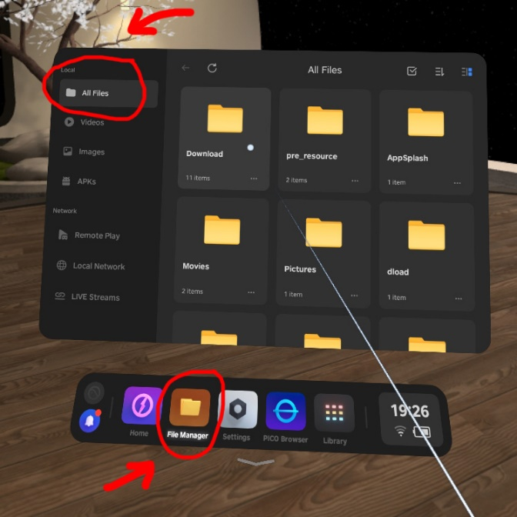
Figure 23 Pico 4 File Manager
- Select the videos and thumbnails that you want to add to the NATUREACH-application, as well as the localization file. Press the scissors icon. Then go back to the “All files” folder (see Figure 24 and Figure 25).
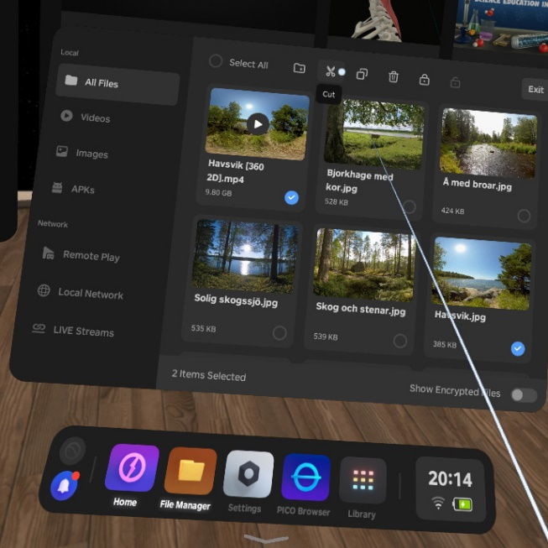
Figure 24 Select Files
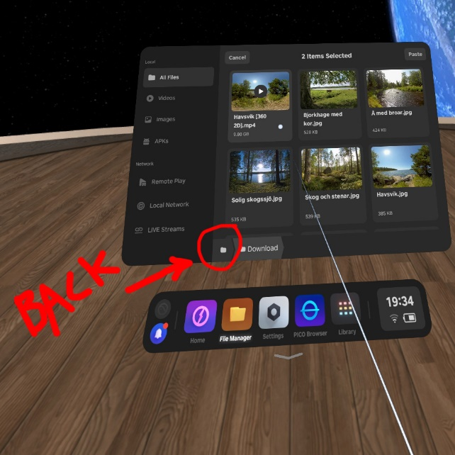
Figure 25 Cut and Return

- From there, navigate to the following folder: All files > Android > data > com.VirtualDawn.NATUREACH360 > files > Videos
Press the “paste” icon in the top right corner to add the files to this folder.
You are now done.
You can repeat this exact procedure with all the headsets you want to use in the project.
If you want a more efficient way to put these files on more than one headset, read the next chapter.

Moving files using an external storage device
This is a good complement to the other two options, especially to the “no computer” way. It is particularly useful if you want to put the files on more than one headset.
In this example we will assume that you previously downloaded the files directly to a VR headset and want to copy them to more VR headsets. However, if you have the files on a computer, it works pretty much the same.
- Take an external storage device of your choice (USB-stick or an external hard drive) and plug it in to the VR headset’s USB-port. When plugged in, the device shows up here (see Figure 26):
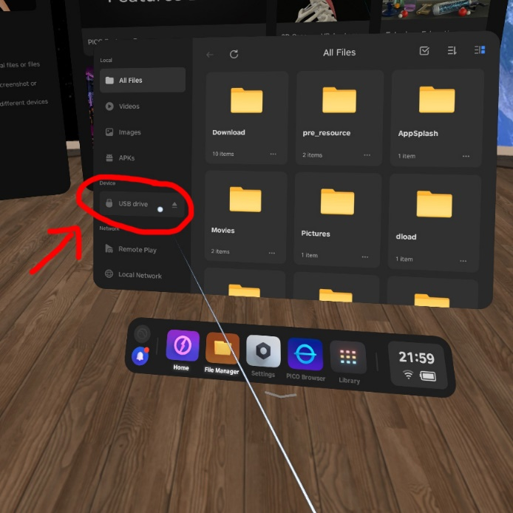
Figure 26 External Devices
- Copy all the files from the VR headset to the “USB Drive”.
Then pull out the storage device, plug it in to the next VR headset and copy the files over to the correct folder on that headset.
For instructions on how to find the right folder, please check out the previous chapter.
Repeat this procedure for all the headsets. Then you are done.

Troubleshooting for External Storage Devices
Here are some potential issues that you can encounter (and how to fix them) when trying to move files using an external storage device:
- The external hard drive or USB-stick does not show up as a “device” in the headset.
If the device is in working condition (shows up fine on a computer), the likely issue is that it has a “file system” that the VR headset does not support. We recommend using the file system ExFAT. To change the file system, you need to plug the device into a computer and format it. Please note that formatting always deletes all the data on the device.
- The device shows up but does not allow me to copy files to it
First double check that you have enough free storage space on the device. If that’s not the issue, the problem can be that the device has the wrong file system. For example, a common file system for USB-sticks is “Fat32” and it doesn’t support file sizes larger than 4GB. Since your video files are much larger, the file transfer won't work. As stated earlier, we recommend the file system ExFat which doesn’t have this limitation.
- The transfer is very slow
Pick a faster storage device. Preferably a relatively new device (SSD or flash drive) that uses at least USB 3.0 (this is often, but not always, indicated by a blue color inside the connector). Speeds can also be slower if the storage device is almost completely full. Avoid this.

NATUREACH-application User Guide

Regular use
The NATUREACH-application operates based on eye tracking. You select things by looking at them. The application’s eye tracking is depicted as a white line or dot that starts from the middle of the user’s gaze and is overlayed on any objects the user looks at. Consequently, during regular use the end user does not require the controllers to operate the application. However, the controllers are required to access the settings menu of the application and for using any features outside of the NATUREACH-application. The standard view, which is presented to the user upon opening the application, is the video menu (see Figure 27).

Figure 27 NATUREACH-application Video Menu

The video menu displays all the videos that have been added to the Videos-folder (see the section on Adding VR nature environments). The video menu has the following functionalities:
- The video menu should be centered based on the users’ head and eye positions. This is calculated when the application is opened. The video menu’s positioning can be adjusted by turning away (to the right or left) until the menu starts following the users’ gaze. Once the menu starts following the user, it can be positioned to the users’ liking.
- Once a good enough position and angle have been found the user can start selecting the video they want to watch. The menu operates on a 3 second delay. This allows the user to look at the video thumbnails for 3 seconds without the selection timer for that video starting. Once a video thumbnail has been looked at for 3 seconds the selection timer starts. The selection timer is 5 seconds, meaning that the total amount of time required to select a video is 8 (3+5) seconds of looking at a thumbnail (see Figure 28).

Figure 28 NATUREACH-application Selecting a Video

- The thumbnails are named based on the application’s language settings. Additionally, the thumbnails might contain icons depicting any necessary information the user might need, such as whether the video is in 180 or 360 degrees, contains movement or is in 3D. This is meant to guide the user in selecting videos that are appropriate for their particular preferences and situation.
- Once a video has been selected the application opens the video view displaying the video’s environment. The video starts playing automatically, playing both video and audio.
- The user can exit the video and return to the video menu by looking down at the exit button located 90 degrees down below the horizon (see Figure 29).
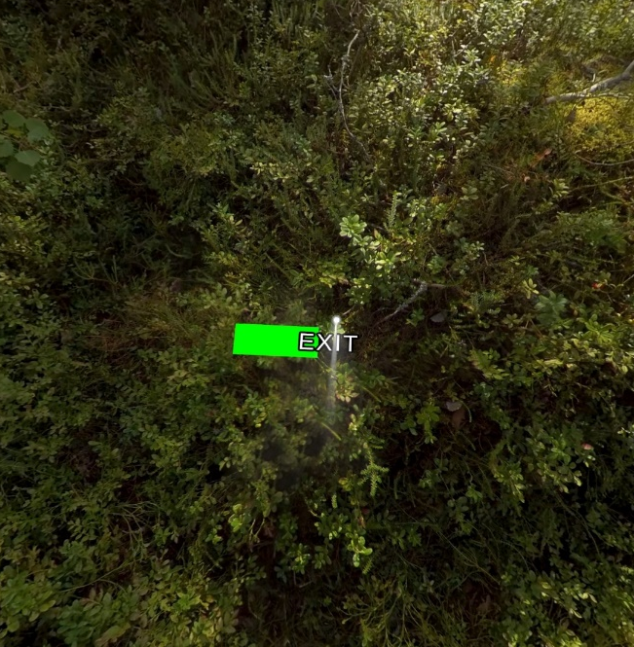
Figure 29 NATUREACH-application Exiting a Video

Configuration
You can configure the application by opening the settings menu. This is accomplished by pressing the right-hand controller’s joystick. This should open the settings menu, which can be used to change the language settings, as well as any other configuration you might need to make.
The application’s eye tracking indicator (white line or dot) can be shifted using the left-hand controller’s joystick. You can change the starting point of the indicator to match the user’s preference. This is an additional feature and should not be used extensively during regular use.

Assisting a patient with the NATUREACH-application
The NATUREACH-application can also be operated via the controllers. This is especially useful in combination with screen casting (see the section on Screen Casting), which enables you to assist a patient with using the VR headset. When the person using the VR headset is looking at a particular video in the video menu, the assisting person can press the A button on the right-hand controller to start the video the person is looking at.
Once a video is playing for the patient, the assisting person can press the B button on the right-hand controller to go back to the video menu. This allows you to operate the NATUREACH-application and assist patients who are unable to use the application by themselves.

Physical Surroundings and Additional Equipment
Editor: Martin, Martta

Using VR with Clients
Working with patients/clients during interventions. + Using the NATUREACH app
Editor: Johan

Screen Casting
Editor: Joni
Screen casting allows you to cast the Pico 4 VR headsets screen to an external device. This is especially helpful when using VR headsets with patients or instructing users on how the VR headset is used (for further instructions on how to assist patients during use see the section on Assisting a Patient with the NATUREACH-application). The Pico 4 has a built-in application for screen casting called Screencast. The application will stop screen casting after a few minutes of inactivity, so it is advised to start the screencast only immediately before use. Casting the VR headsets screen requires you to connect the VR headset and the device you want to cast the screen to the same network. For instructions on connecting the Pico 4 VR headset to a network see the chapter on how to Connect to a Network. The screen casting should work with any device that can connect to a network and has a browser. Once you have connected them to the same network you can start screen casting by following these steps:
- Open the Library menu (see Figure 30).
- Open the Screencast application (see Figure 30).

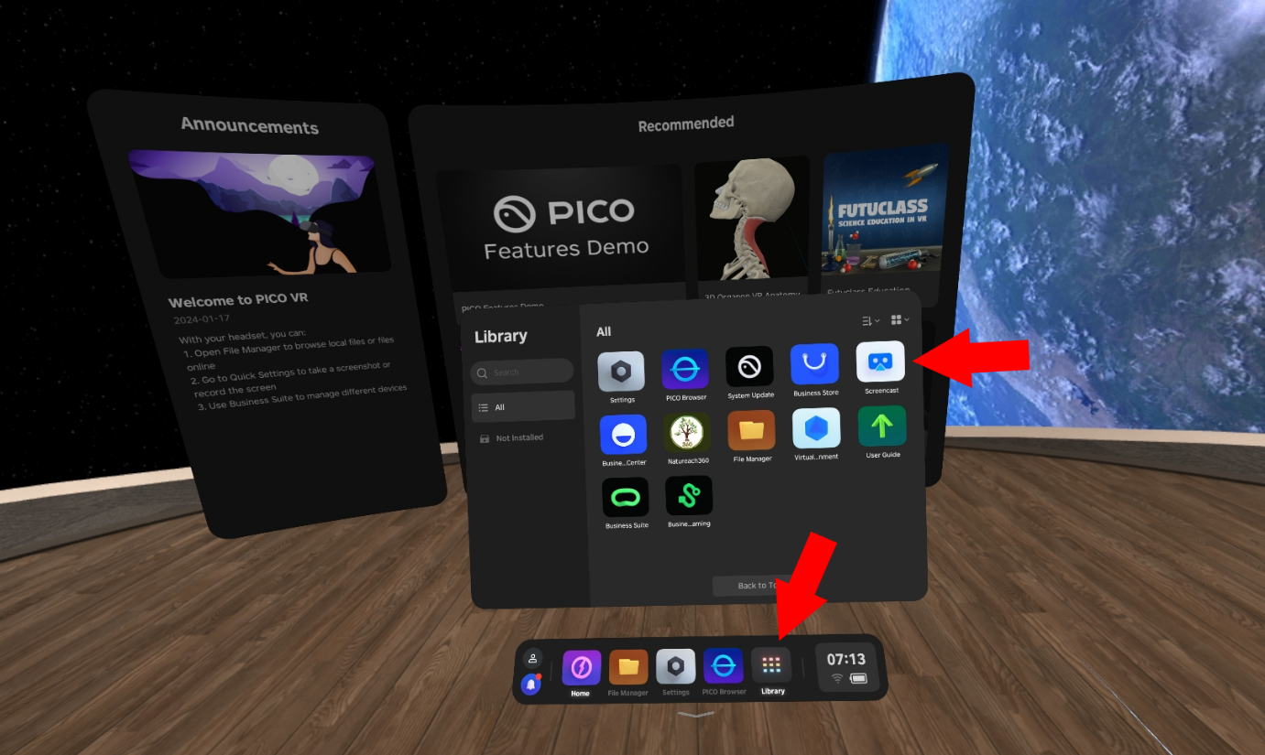
Figure 30 Screencast Application

- Select the option to Cast to Browser (see Figure 31).
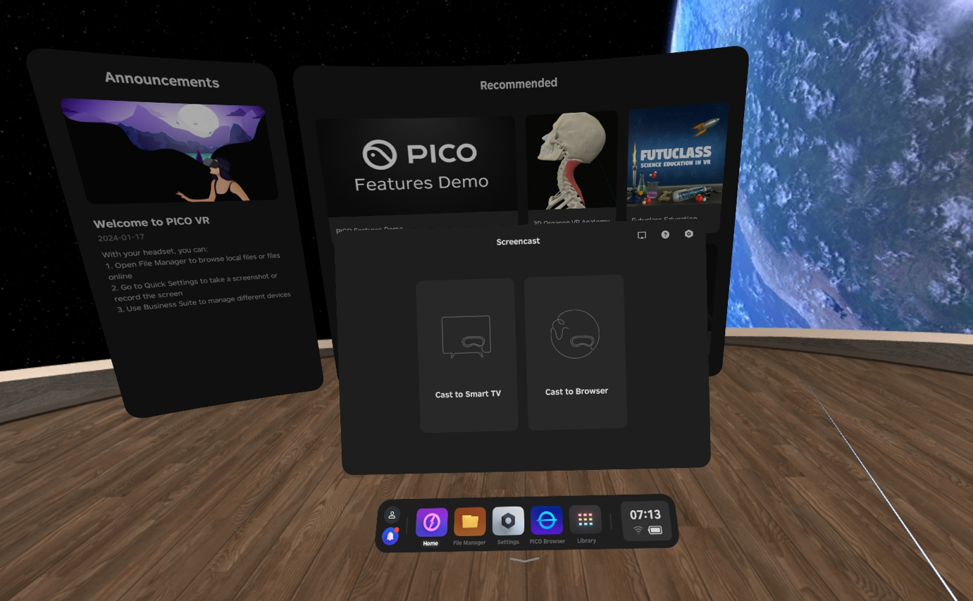
Figure 31 Cast to Browser
- You should see an IP address in the Screencast application (see Figure 32). The address will be different each time you cast the screen.
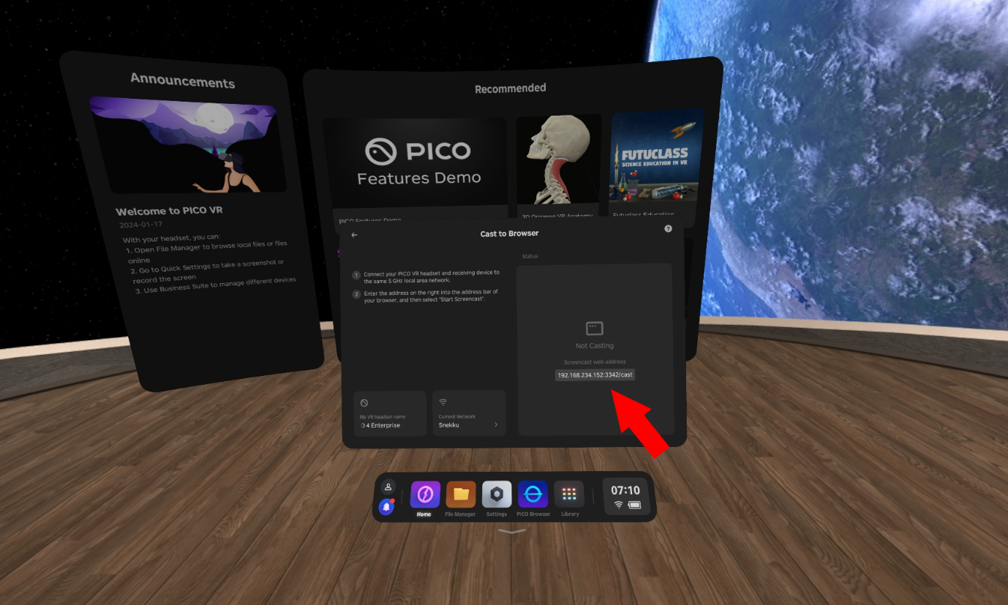
Figure 32 Screen Casting Address
- Open a web browser on the device you want to cast the screen to. Write the address into the address bar of the browser.
- On the website press the option to Start Screencast (see Figure 33).
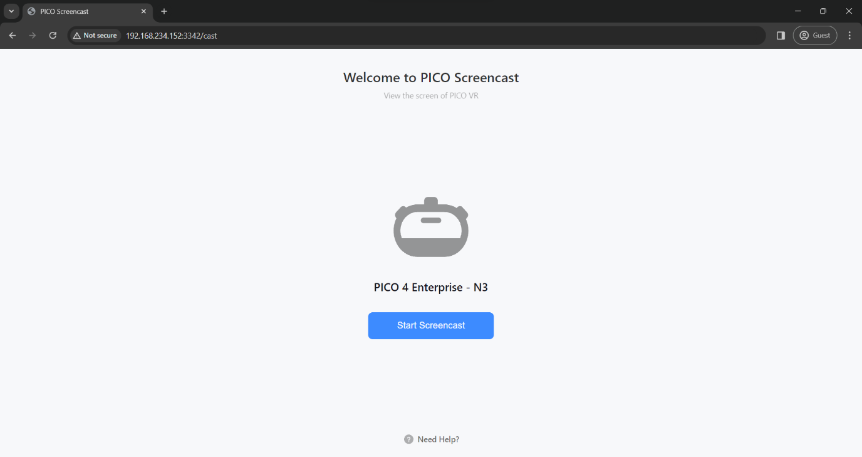
Figure 33 Start Screencast
- You should see a pop-up on your Pico 4 VR headset. Select the option to Allow Screen casting to an External Device (see Figure 34).
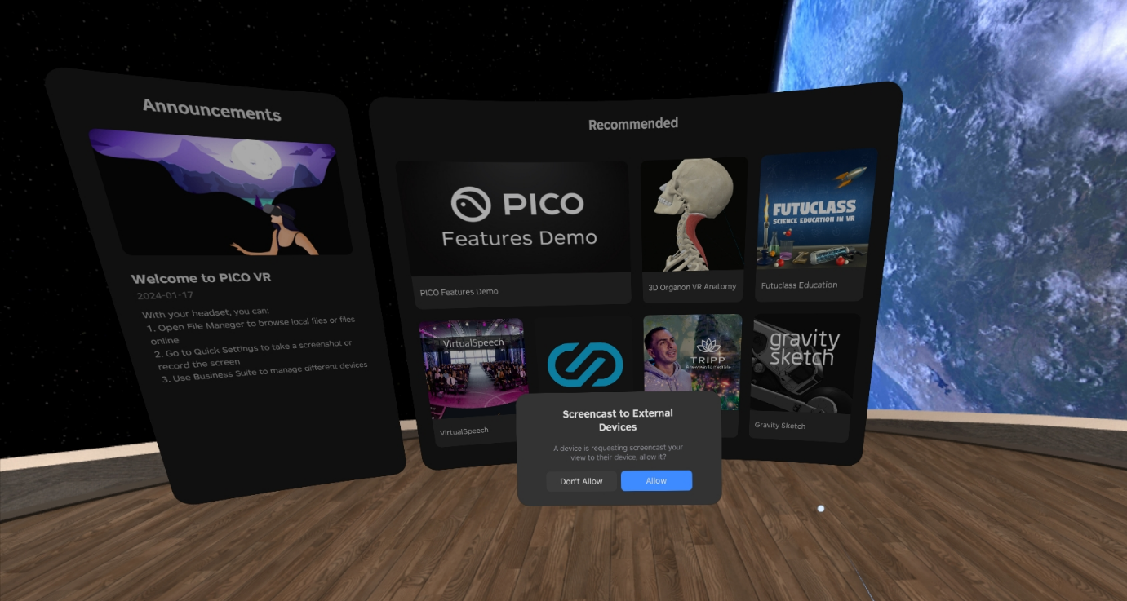
Figure 34 Screencast to External Device

- The Pico 4 VR headsets screen should now be cast to the external device. You can quit casting the screen by either pressing the option to End Screencast in the browser on your external device or by navigating to the Screencast application on your Pico 4 VR headset and selecting the End option (see Figure 35).
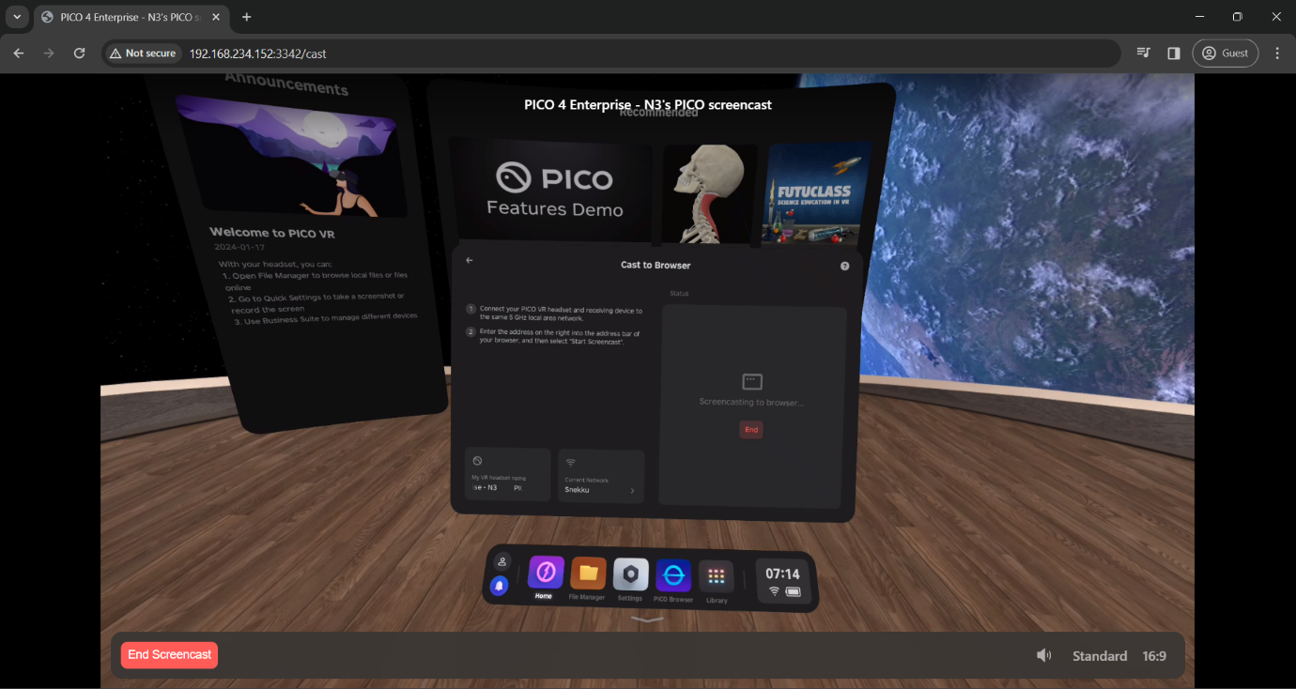
Figure 35 End Screencast

Data Collection
Editor: Jyri, Bettan

Troubleshooting / FAQ
Anyone can add stuff along the way.

Missing Exit button
During our testing we have encountered an issue where the Exit button has been missing a few times. We do not currently know when or why this issue occurs, but it can be remedied by restarting the NATUREACH-application.

Maintenance
Editor: Vaiva, Joni, Martin

Hygienic Use of VR headset
Sanitize the headset thoroughly before and after each person uses it. Sanitize the headset before giving it to the next person. You can clean the headset with non-abrasive antibacterial wipes. Carefully wipe the face cushion, light blocker, and nose area – as well as the headset body, including the headband adjustment wheel and buttons. Do not use soap, harsh chemicals, cleaning solvents, liquids, or aerosols for cleaning the headset as they can cause damage to the device.
Clean the headset lenses very carefully due to their close contact with your eyes. Wipe the lenses gently with a microfiber lens cloth.
Maintain personal hygiene. Wash your hands (if possible) thoroughly before and after putting the headset on.

Charging
The Pico 4 VR headset has a battery life of approximately 3 hours. This means that the VR headset can be used for a maximum amount of 3 hours consecutively before running out of power. The batteries are also drained when the headset is left unused for extended periods of time.
Preferably, the VR headset should be charged periodically, for instance after each prolonged use or sometime before an intervention.

Avoid exposing the VR headset lenses to direct sunlight
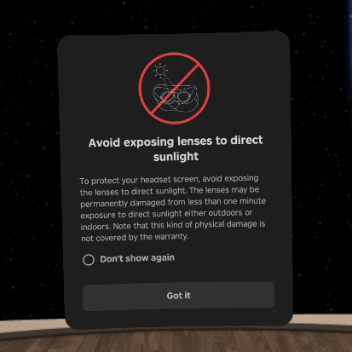

Contact Information
Editor: Martin
If you encounter any issues or have any questions these are the people to turn to:
Martin Gärdemalm: Any questions regarding the videos or the video files. I’m also happy to hear any feedback on the videos you might have along the way.
martin.gardemalm@slu.se
+4673-0589172
Joni Piispanen: Any questions regarding the software (video player) and any general technical questions regarding VR headset hardware (buttons, controllers, battery etc.). Also any questions regarding connections between VR headsets and computers. Any feedback on the video player can also go to Joni.
joni.piispanen@uwasa.fi
Johan Jirlén: General technical questions.
johan.jirlen@ltu.se

